#1) Binary arithmetic: In order to get full credit you need to pass in your work. You can give it to me on paper, scan it, take a picture of it or whatever creative method will work for both of us!

1111  1100  + 11 | 11001  111  + 1001 | 10011  11111  00111  + 11001
11011  - 101 | 10001  - 111 | 11101  - 111

#2) I wrote a text file in notepad and then opened it so that you could see the hexadecimal translation of what I wrote. Look at the hexadecimal translation and then tell me what I wrote for the last two lines. Your answers should be in character (be aware of cases).

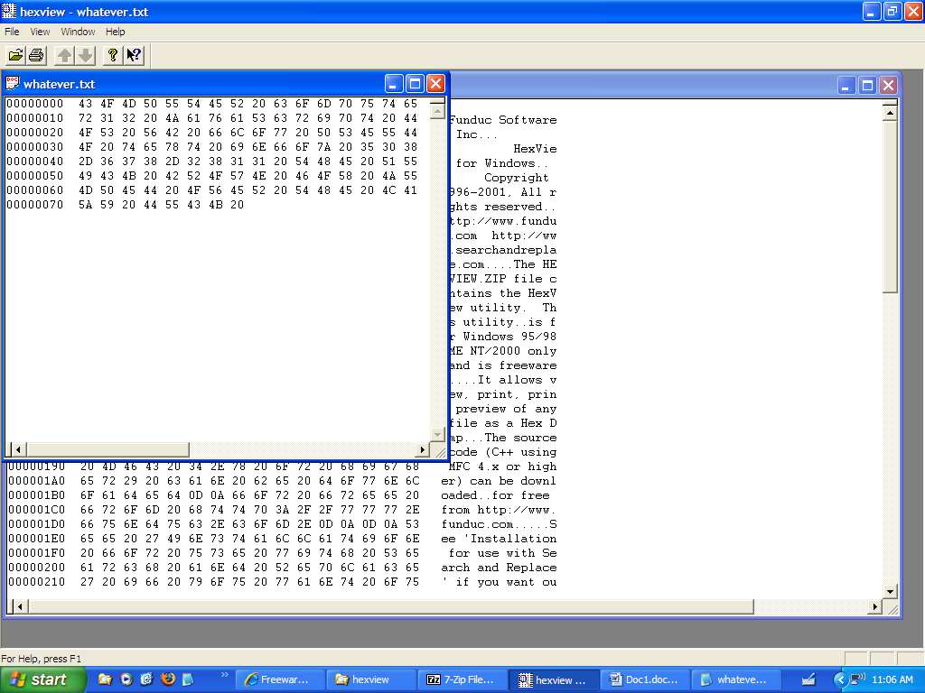

#3) Write the ASCII 8 bit code (that means the 8 0s and 1s) for the following hex

4B 38 74 6A 51

#4) Give me the hexadecimal and the character (letters, numbers etc) for the following ASCII 8 bit code:

01100101 01001111 01110010 01001110 01001101 00110111

#5) Write the ASCII 8 bit code for the following:

First59
Quiz

#6) What is the decimal and the character for the following ASCII

01010101 01111001 00110100 01001000 01110101

