#1) I wrote a text file in notepad and then opened it so that you could see the hexadecimal translation of what I wrote. Look at the hexadecimal translation and then tell me what I wrote for the first four lines. Your answers should be in character (be aware of cases).

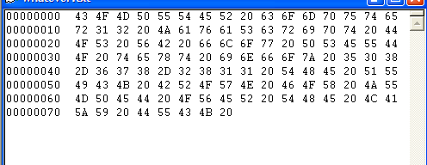

#2) Write the ASCII 8 bit code (that means the 8 0s and 1s) for the following hex (see above)

53 4E 4F 57

4B 38 74 6A 51

#3) Give me the hexadecimal and the character (letters, numbers etc) for the following ASCII 8 bit code:

01100111 01001010 01110110 01001111 01001100

01100101 01001110 01110010 01001111 01001101 00110111

#4) Write the ASCII 8 bit code for the following:

CIS120
Major
Quiz

#5) What is the decimal and the character for the following ASCII

01010101 01111001 00110100 01001000 01110110

#6) Hexadecimal/decimal conversion:

D4 in hexadecimal = __________________ in decimal

536 in decimal = _______________________ in hexadecimal

ABC in hexadecimal = _______________________ in decimal

7635 in decimal = _______________ in hexadecimal

#6) Binary/hexadecimal conversion:

1101001111001111101 in binary = _____________ in hex

C6E in hex = ___________________ in binary

100110001010111011010010 in binary = _______________ in hex

F79D in hex = _______________________in binary

