I would like you to write this JavaScript page. We will work on it this week and go over the solution next week so it needs to be in next Monday.

Note that the medical plans subtract 50, 35 and 25 for the three possibilities. A is subtract 50, B is subtract 35 and C is subtract 25.
If you use salary:
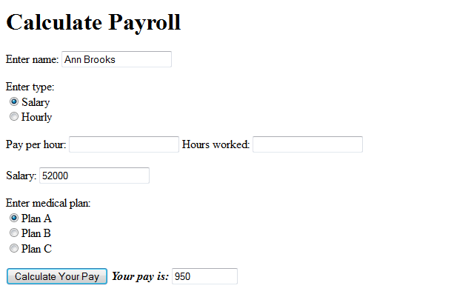
If you use hours:
