Script to create emp table (createemp.sql)
You can enter edit createemp.sql or another name at the SQL prompt. It will go into the editor and ask if you want to create a new script. Enter yes and paste the script in and save it. Return to the prompt and enter @ createemp.sql and it should run and create the table for you.
If you are using putty, remember to have the script text in notepad and highlight it and I suggest selecting copy if the other does not work. When you go into the editor the right click will paste it or you can uses shift + ins to paste. You can then write and exit. Back at the SQL prompt is where you run it with the @.
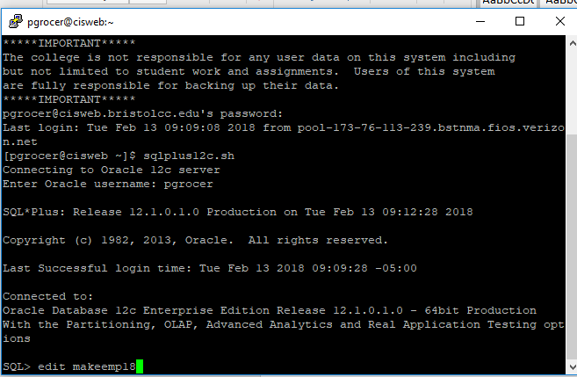
I am now going into the editor. I have the text I want in notepad and it is highlighted. I have found that if it is being difficult sometimes selecting copy in notepad helps.
The screen comes up as shown on the next page and this is where you do the right click to paste what is in notepad into the editor. The next page shows before the right click and after the right click.
Note that on the second slide on the next page you select Write Out which is ^O to write out the next in the script. After the Write Out, it will prompt you to save the text as makeemp18.sql and you click enter. Then you use ^X to exit. At this point you want to execute the script with @ makeemp18 and the table with data will be created.
