Basic CSS Exercise

Send me the answer to #1 and the answer to #2 as attachments if you do not complete them in class and get my ok.

Definitions for where we are now:
- The selector is the HTML tag that you are working with
- The declaration tells what to do with the element that is selected. It has both a property and a value. It is enclosed in { } brackets
- The property defines the attribute and ends with a colon
- The value tells the impact on the attribute and a semi-colon is used to end each declaration

#1. Look at the CSS below and tell me what the selector is, what the declaration is, what the property is and what the value is:

p
{
color: green;
}

#2 This is what I want to see:

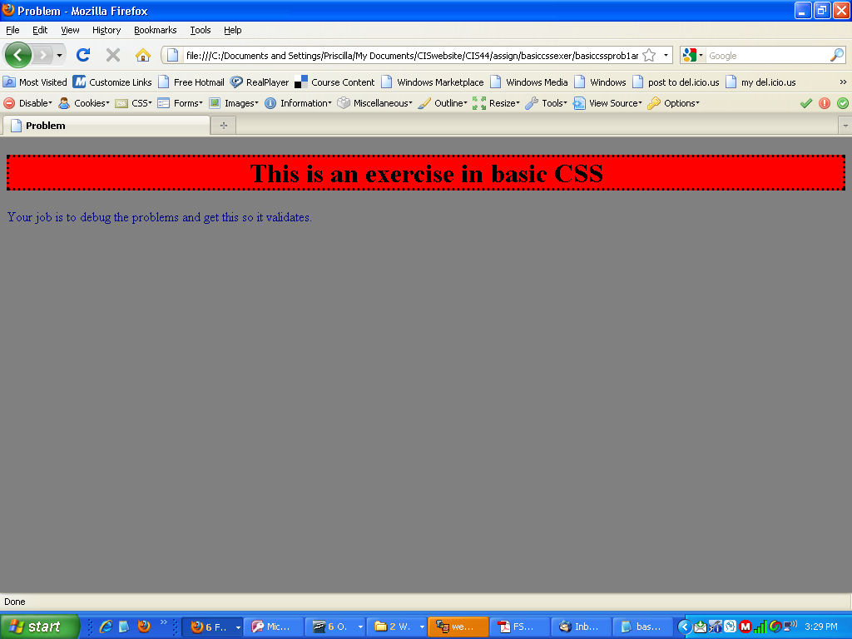
You can download the code that contains errors from.
http://cisweb.bristolcc.edu/~pgrocer/CIS44/basiccssexer/basiccssprob1.html

You should then fix the errors on your copy and validate.

