ASSIGNMENT: I want you to create this using HTML5/JavaScript. I want you to do it multiple ways.
Each way should have a function to total and a function to clear.

We started this in class and the progress can be seen on the Smartboard. I want you to do the code and you can use mine for help but really work at understanding what is happening! Extra credit if you come up with a different way to solve the problem.
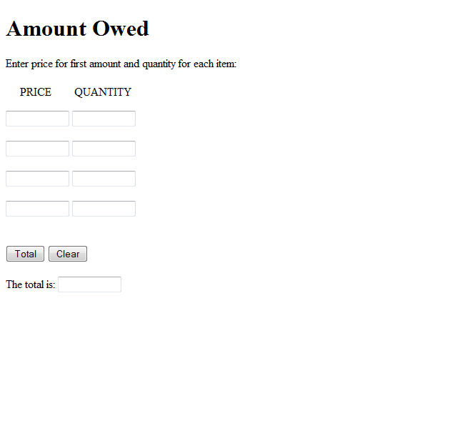
Note to those in class: The clearTotal on the version I gave you was not the one I intended to give you – I had put errors into it to debug and then...

