ASSIGNMENT: I want you to create this using HTML5/JavaScript. I want you to do it multiple ways.
Each way should have a function to total and a function to clear.

- First create it by calling the function and passing nothing. This means you need very complete addresses for the information on the form.
- Pass the information to the functions and fill the Total from within the function.
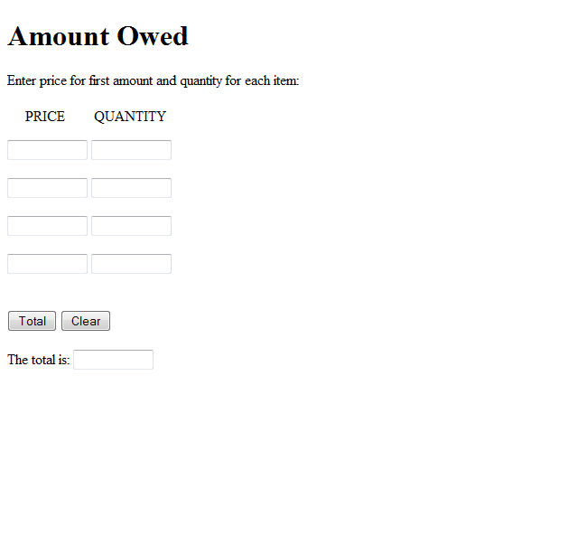
- Pass the information to the functions and return the answer which you place as a result of the on click event.

