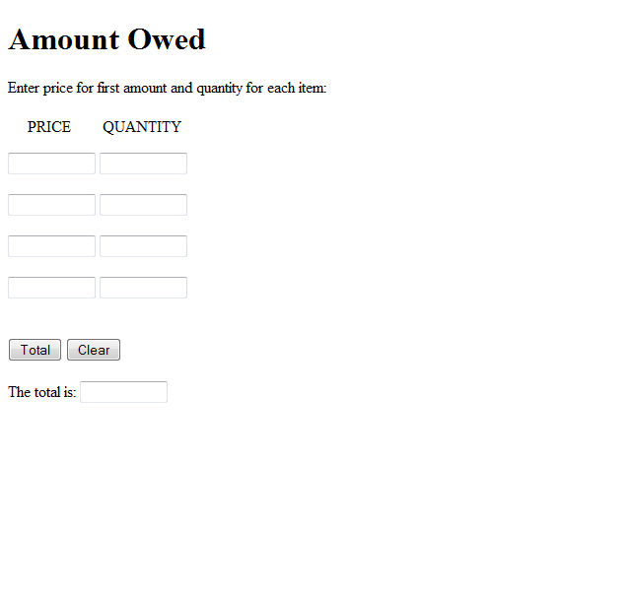
ASSIGNMENT: I want you to create this using HTML5/JavaScript. You must use a function.

