Basic CSS Exercise

Definitions for where we are now:
- The selector is the HTML tag that you are working with
- The declaration tells what to do with the element that is selected. It has both a property and a value. It is enclosed in { } brackets
- The property defines the attribute and ends with a colon
- The value tells the impact on the attribute and a semi-colon is used to end each declaration

#1. Look at the CSS below and tell me what the selector is, what the declaration is, what the property is and what the value is:

p
{
color: green;
}

#2 This is what I want to see:

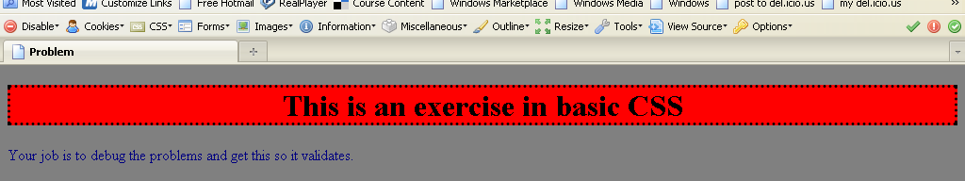
You can download the code that contains errors from:
http://www.pgrocer.net/Cis44/assignments1112/inclass3rd1112/basiccssprob1.html

You should then fix the errors on your copy and validate.

#3 This program has to be changed to use CSS – it now uses style from a pre CSS time.
You can download it from:
http://www.pgrocer.net/Cis44/assignments1112/inclass3rd1112/withstyleerrors.html

#4 This program does not validate. You need to fix it up so it does.
You can download it from:
http://www.pgrocer.net/Cis44/assignments1112/inclass3rd1112/tofixpartofasgn.html

