books1.xml

<?xml version="1.0" encoding="UTF-8" standalone="yes" ?>
<!-- Data on Childrens Books -->
<HALLBOOKCASE>
<CATEGORY>Books in the hall bookcase</CATEGORY>
<SUBJECT>Talking Animal
<AUTHOR>Thorton Burgess</AUTHOR>
<TITLE>The Adventures of Reddy Fox</TITLE>
<TITLE>The Adventures of Peter Rabbit</TITLE>
<TITLE>The Adventures of Lightfoot the Deer</TITLE>
<TITLE>The Adventures of Buster Bear</TITLE>
<TITLE>The Adventures of Jimmy Skunk</TITLE>
</SUBJECT>
<SUBJECT>Pioneer Life
<AUTHOR>Laura Ingles Wilder</AUTHOR>
<TITLE>Little House on the Prairie</TITLE>
</SUBJECT>
<SUBJECT>Colonial Times
<AUTHOR>Alice Turner Curtis</AUTHOR>
<TITLE>A Little Maid of Bunker Hill</TITLE>
<TITLE>A Little Maid of Virginia</TITLE>
</SUBJECT>
</HALLBOOKCASE>
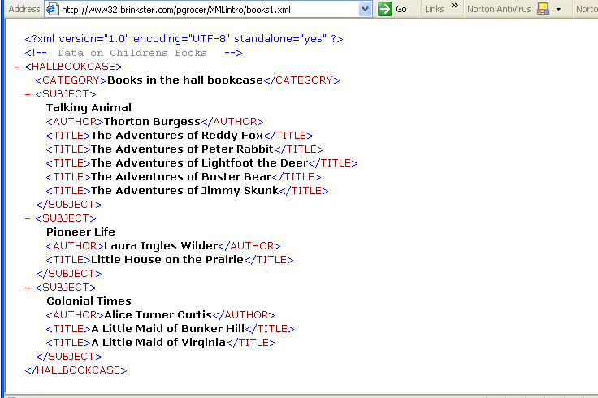

<?xml version="1.0" encoding="UTF-8" standalone="yes" ?>
<!-- Data on Childrens Books -->

books2.xml

<?xml-stylesheet type="text/css" href="bookscss.css" ?>
<HALLBOOKCASE>
<CATEGORY>Books in the hall bookcase</CATEGORY>
<SUBJECT>Talking Animal
<AUTHOR>Thorton Burgess</AUTHOR>
<TITLE>The Adventures of Reddy Fox</TITLE>
<TITLE>The Adventures of Peter Rabbit</TITLE>
<TITLE>The Adventures of Lightfoot the Deer</TITLE>
<TITLE>The Adventures of Buster Bear</TITLE>
<TITLE>The Adventures of Jimmy Skunk</TITLE>
</SUBJECT>
<SUBJECT>Pioneer Life
<AUTHOR>Laura Ingles Wilder</AUTHOR>
<TITLE>Little House on the Prairie</TITLE>
</SUBJECT>
<SUBJECT>Colonial Times
<AUTHOR>Alice Turner Curtis</AUTHOR>
<TITLE>A Little Maid of Bunker Hill</TITLE>
<TITLE>A Little Maid of Virginia</TITLE>
</SUBJECT>
</HALLBOOKCASE>

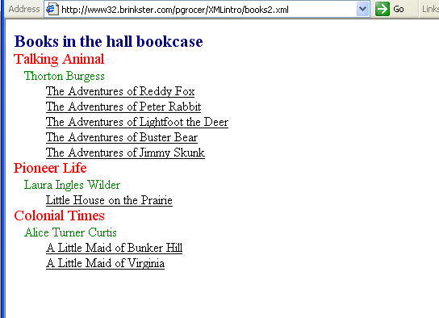

payroll.xml

<?xml version="1.0" ?>
<!-- Data for Payroll -->
<PERSONNEL>
<EMPLOYEE>
<FIRST_NAME>Stephen</FIRST_NAME>
<LAST_NAME>Daniels</LAST_NAME>
<DEPT>Sports</DEPT>
<JOB>Reporter</JOB>
<SALARY>50000</SALARY>
</EMPLOYEE>
<EMPLOYEE>
<FIRST_NAME>Al</FIRST_NAME>
<LAST_NAME>Richards</LAST_NAME>
<DEPT>Engineering</DEPT>
<JOB>Consultant</JOB>
<SALARY>95000</SALARY>
</EMPLOYEE>
<EMPLOYEE>
<FIRST_NAME>Jennifer</FIRST_NAME>
<LAST_NAME>Ames</LAST_NAME>
<DEPT>Foreign</DEPT>
<JOB>Consultant</JOB>
<SALARY>55000</SALARY>
</EMPLOYEE>
<EMPLOYEE>
<FIRST_NAME>Sarah</FIRST_NAME>
<LAST_NAME>Grant</LAST_NAME>
<DEPT>Scientific</DEPT>
<JOB>Web</JOB>
<SALARY>50000</SALARY>
</EMPLOYEE>
<EMPLOYEE>
<FIRST_NAME>Carl</FIRST_NAME>
<LAST_NAME>Hersey</LAST_NAME>
<DEPT>Foreign</DEPT>
<JOB>Consultant</JOB>
<SALARY>60000</SALARY>
</EMPLOYEE>
</PERSONNEL>

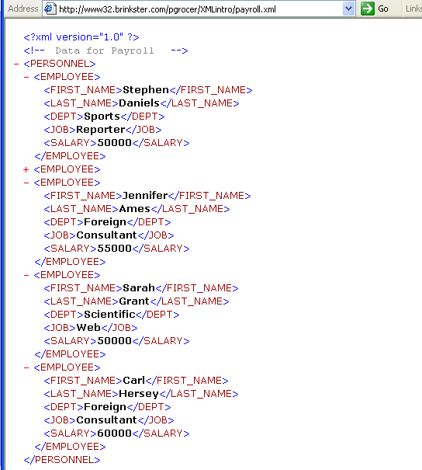

payroll.html

<html>
<head><title>Fall River Management</title>
<style>
body {
background:beige;
}
#Page_Header
{
font-style:bold;
font-size: 26pt;
text-align:center;
color:brown;
}
#Sub_Header
{
font-style:bold;
font-size: 22pt;
text-align:center;
color:brown;
}
#List_Header
{
font-size:16pt;
color:brown;
border-bottom: solid 1 brown;
}
table
{
color:brown;
border:solid thin brown;
}
.fortable
{
border:solid thin brown;
bordercolordark:brown;
bordercolorlight:brown;
width:300pt;
}
.forbutton
{
color:beige;
background:brown;
}
</style>
<body>
<xml id="Personnel_Data" src="payroll.xml"></xml>
<p id="Page_Header">Fall River Management</p>
<p id="Sub_Header">777 Elsbree Street<br>Fall River, MA</p>
<p id="List_Header">Personnel List</p>
<table class="fortable">
<tr>
<td class="fortable">First Name:</td>
<td class="fortable"><span datasrc="#Personnel_Data" datafld="FIRST_NAME"></span></td>
</tr>
<tr>
<td class="fortable">Last Name:</td>
<td class="fortable"><span datasrc="#Personnel_Data" datafld="LAST_NAME"></span></td>
</tr>
<tr>
<td class="fortable">Department:</td>
<td class="fortable"><span datasrc="#Personnel_Data" datafld="DEPT"></span></td>
</tr>
<tr>
<td class="fortable">Job:</td>
<td class="fortable"><span datasrc="#Personnel_Data" datafld="JOB"></span></td>
</tr>
<tr>
<td class="fortable">Salary:</td>
<td class="fortable"><span datasrc="#Personnel_Data" datafld="SALARY"></span></td>
</tr>
</table>
<br /><br /><br />
<button class="forbutton" onClick="Personnel_Data.recordset.moveFirst()">First</button>
<button class="forbutton" onClick="Personnel_Data.recordset.movePrevious();
if (Personnel_Data.recordset.BOF) Personnel_Data.recordset.moveFirst()">
Previous</button>
<button class="forbutton" onClick="Personnel_Data.recordset.moveNext();
if (Personnel_Data.recordset.EOF) Personnel_Data.recordset.moveLast()">
Next</button>
<button class="forbutton" onClick="Personnel_Data.recordset.moveLast()">Last</button>
</body>
</html>

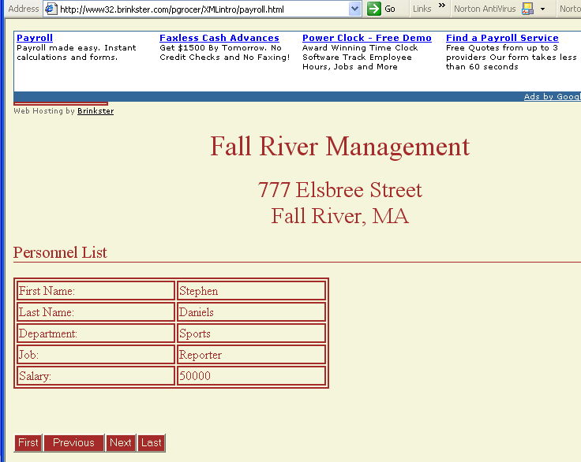

paymulti.html

<html>
<head><title>Fall River Management</title>
<style>
body {
background:beige;
}
#Page_Header
{
font-style:bold;
font-size: 26pt;
text-align:center;
color:brown;
}
#Sub_Header
{
font-style:bold;
font-size: 22pt;
text-align:center;
color:brown;
}
#List_Header
{
font-size:16pt;
color:brown;
border-bottom: solid 1 brown;
}
table
{
color:brown;
border:solid thin brown;
}
th
{
border:solid thin beige;
background: brown;
color: beige;
width:80pt;
}
.fortable
{
border:solid thin brown;
bordercolordark:brown;
bordercolorlight:brown;
width:400pt;
}
.forcell
{
border:solid thin brown;
text-align:center;
width:80pt;
}
.forbutton
{
color:beige;
background:brown;
}
</style>
<body>
<xml id="Personnel_Data" src="payroll.xml"></xml>
<p id="Page_Header">Fall River Management</p>
<p id="Sub_Header">777 Elsbree Street<br>Fall River, MA</p>
<p id="List_Header">Personnel List</p>
<table class="fortable" datasrc="#Personnel_Data">
<thead>
<th>First Name</th>
<th>Last Name</th>
<th>Department</th>
<th>Job</th>
<th>Salary</th>
</thead>
<tr>
<td><span class="forcell" datafld="FIRST_NAME"></span>
</td>
<td><span class="forcell" datafld="LAST_NAME"></span>
</td>
<td><span class="forcell" datafld="DEPT"></span>
</td>
<td><span class="forcell" datafld="JOB"></span>
</td>
<td><span class="forcell" datafld="SALARY"></span>
</td>
</tr>
</table>
</body>
</html>

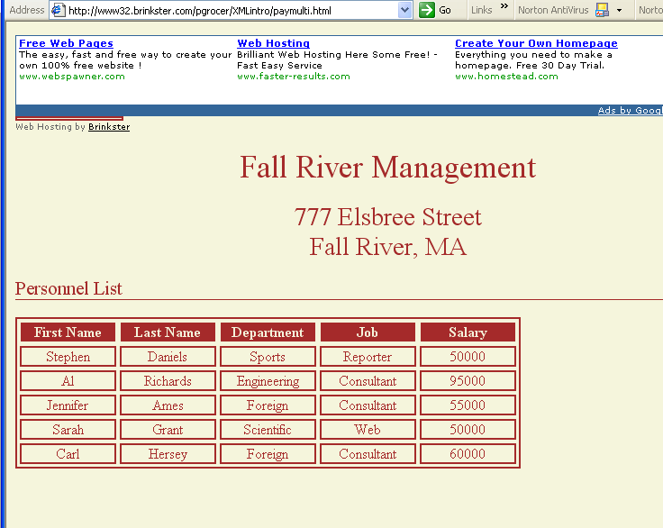

pay2per.html

<html>
<head><title>Fall River Management</title>
<style>
body {
background:beige;
}
#Page_Header
{
font-style:bold;
font-size: 26pt;
text-align:center;
color:brown;
}
#Sub_Header
{
font-style:bold;
font-size: 22pt;
text-align:center;
color:brown;
}
#List_Header
{
font-size:16pt;
color:brown;
border-bottom: solid 1 brown;
}
table
{
color:brown;
border:solid thin brown;
}
th
{
border:solid thin beige;
background: brown;
color: beige;
width:80pt;
}
.fortable
{
border:solid thin brown;
bordercolordark:brown;
bordercolorlight:brown;
width:400pt;
}
.forcell
{
border:solid thin brown;
text-align:center;
width:80pt;
}
.forbutton
{
color:beige;
background:brown;
}
</style>
<body>
<xml id="Personnel_Data" src="payroll.xml"></xml>
<p id="Page_Header">Fall River Management</p>
<p id="Sub_Header">777 Elsbree Street<br>Fall River, MA</p>
<p id="List_Header">Personnel List</p>
<table class="fortable" datasrc="#Personnel_Data" id="persTable" datapagesize="2">
<thead>
<th>First Name</th>
<th>Last Name</th>
<th>Department</th>
<th>Job</th>
<th>Salary</th>
</thead>
<tr>
<td><span class="forcell" datafld="FIRST_NAME"></span>
</td>
<td><span class="forcell" datafld="LAST_NAME"></span>
</td>
<td><span class="forcell" datafld="DEPT"></span>
</td>
<td><span class="forcell" datafld="JOB"></span>
</td>
<td><span class="forcell" datafld="SALARY"></span>
</td>
</tr>
</table>
<br /><br /><br />
<button class="forbutton" onClick="persTable.firstPage()">First</button>
<button class="forbutton" onClick="persTable.previousPage();
if (Personnel_Data.recordset.BOF) persTable.firstPage()">
Previous</button>
<button class="forbutton" onClick="persTable.nextPage();
if (Personnel_Data.recordset.EOF) persTable.lastPage()">
Next</button>
<button class="forbutton" onClick="persTable.lastPage()">Last</button>
</body>
</html>

