Note that 11g Express Addition is different then the full version (this was true in 10g as well).
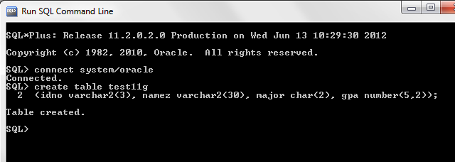
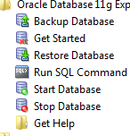
To use 11g Express, you need to start out with Start Database and then at the end you will need to use Stop Database. For this introduction, I am using the SQL Command which lets you work directly with SQL and follow my notes.

Note that here I connected to Oracle at the SQL prompt and then I can start doing the SQL described at my site. First I am inserting a record.. Note that I made a mistake and had to redo. I thought I had made the idno 5 characters instead of 3.

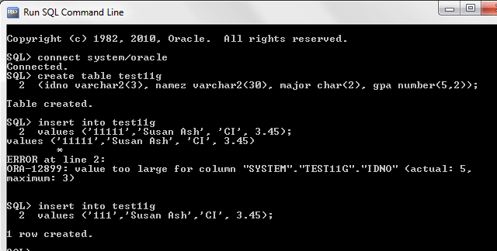
Now I am going to add two more records - note that I made a mistake and game the table the wrong name in one of my inserts. After I inserted 3 records, I selected them to view using select * which selects all records and then I did a desc which shows the structure of the table that was created originally with the create command.

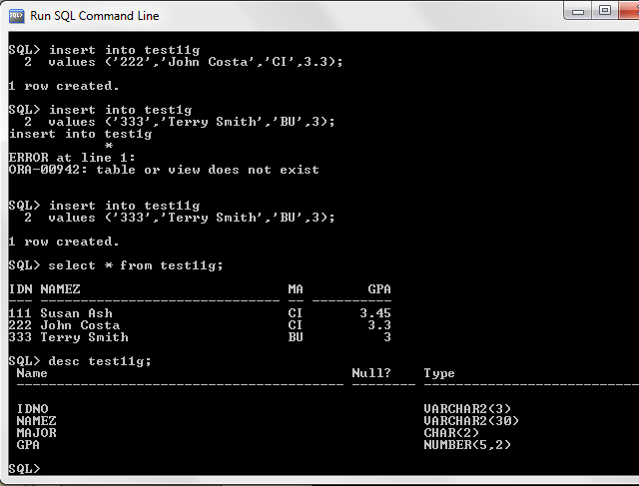
Now I am going to select a record meeting a certain criteria - I want only CI majors. To do this I use the where clause where I set the condition of major = 'CI'.
Then I am going to insert another record and decide that I want to make a change to that record so I am going to update the record. The where clause is important here to limit the scope of the update. If I do not have the where clause then all of the records will change using the set command.

Note that to be sure your data is saved you should use the commit command to commit the data you added.
