Importing Oracle Sample Tables
Below Example> Logging into cisweb and importing tables
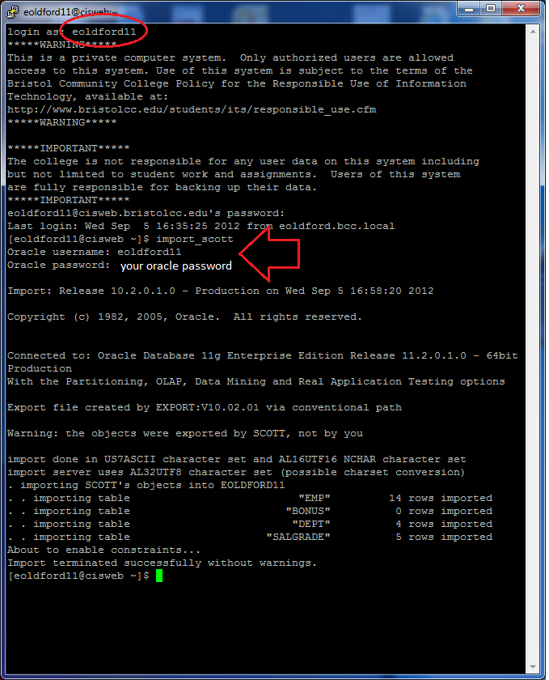

Instructions
- Log in to cisweb with putty
Use your username and Linux password

- Type import_scott and hit Enter

- Enter your username and Oracle password

- Check by logging in to Oracle with sqlplus11g.sh

- Type select * from cat; to verify the tables were copied

Below Example> Logging in to Oracle to check tables
