Installing Oracle 9i on XP Pro.

You need a file decompression program like Winrar or Winzip if you don’t already have one.

I like Winrar – if you don’t buy it, it will just bug you but not force you to buy it.
These can be found on www.cnet.com. Just search for them and download and run. If you get firewall notices, bypass them.

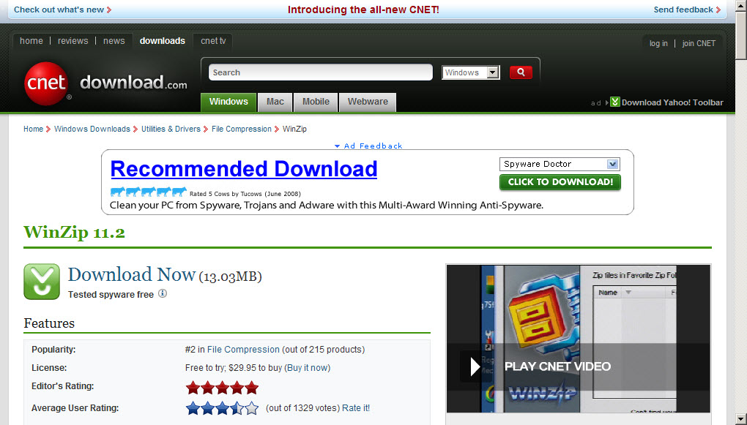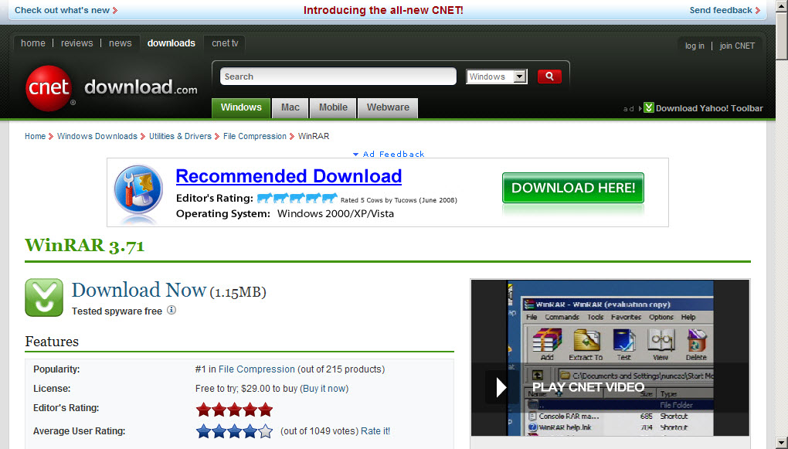

If you went to the oracle site and tried to download Oracle 9i, it probably wouldn’t let you because you have to register with Oracle. My guess would be that Oracle wants you to know what you’re doing before you download an older version.

Go here: http://www.oracle.com/technology/software/index.html
And then click on the little link at the top right that says ‘sign in/register for account’.

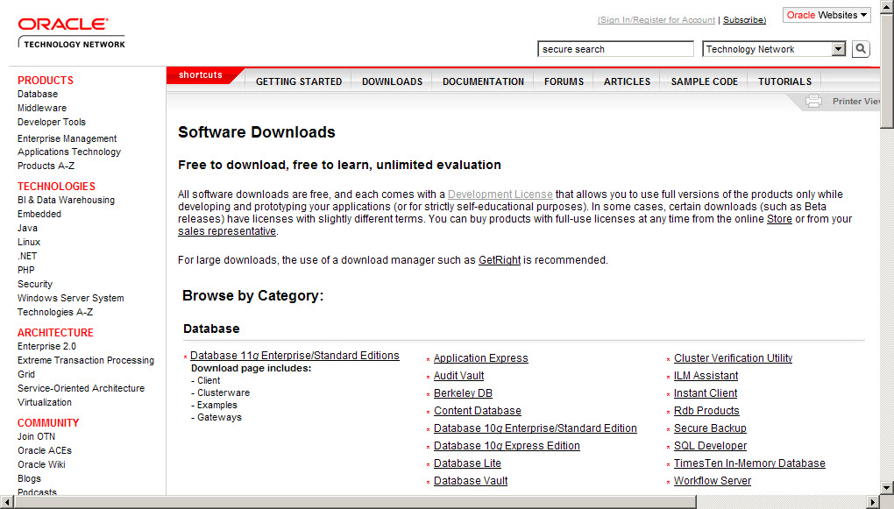

The following window will appear – complete it.

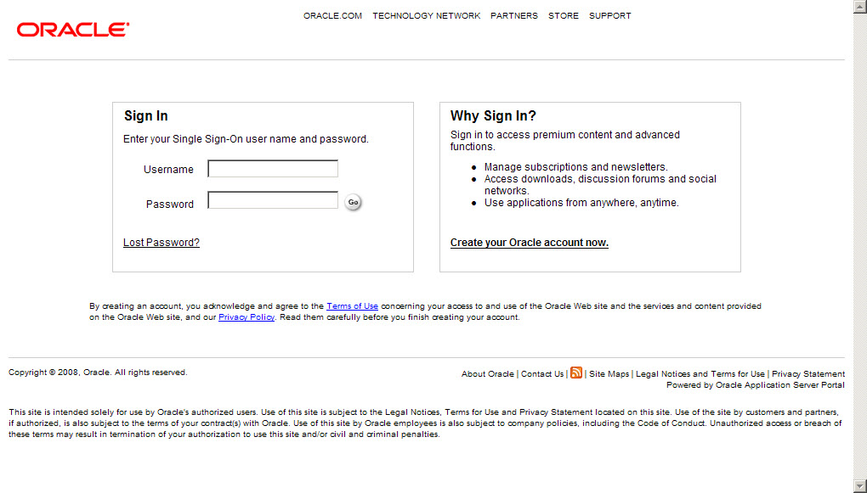
Click on “create your oracle account now.”
Don’t worry, it’s free – we’re students.

Then this screen will appear – put in your email address that you want to use and a password of your choice. You can use your home email address.

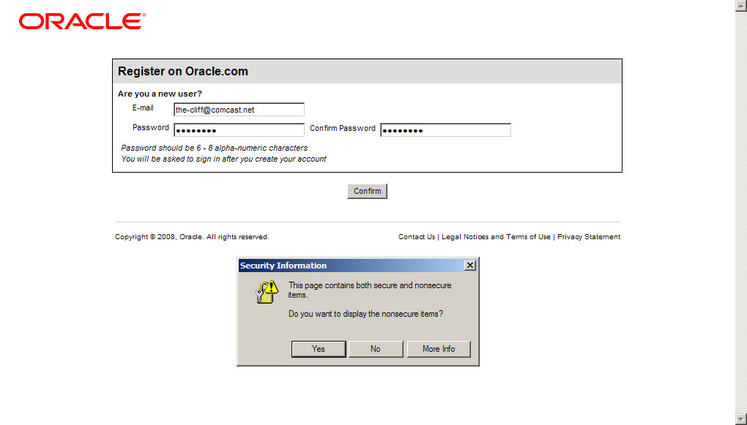
If you get any security windows, let them pass.

You will then open this form window. Complete it making sure that all fields are filled in. I listed my self at BCC as a student.

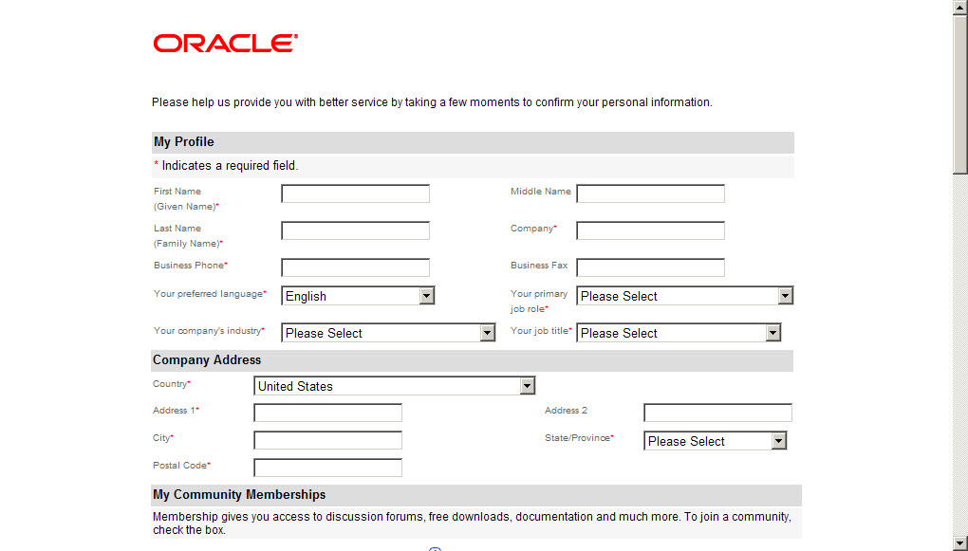

You can scroll down to join Oracle communities at this point if you want.

You should be taken back to the software screen. If not, re-enter the software link from above and if needed log-in.

Select Oracle9i Database Release 2 Enterprise/Standard/Personal Edition for Windows NT/2000/XP/2003.

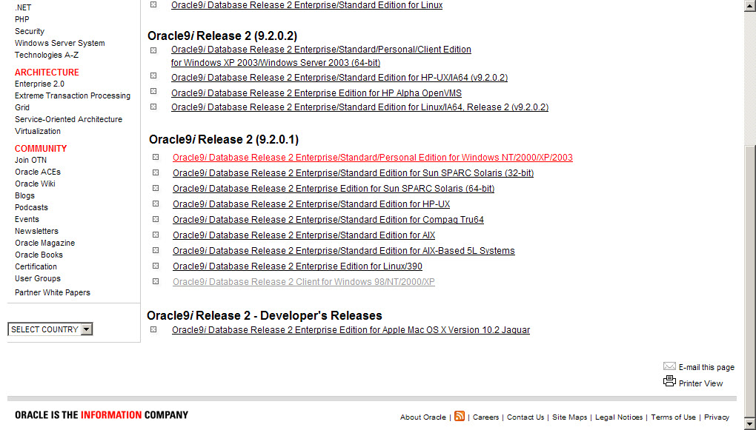

On the next screen click ACCEPT.
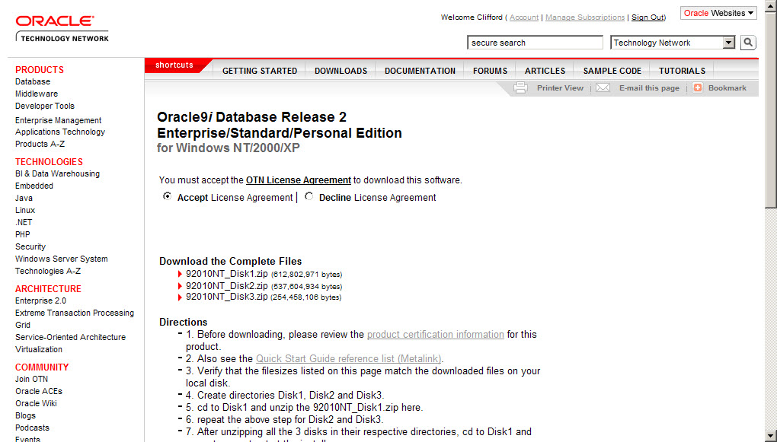

Do yourself a favor and READ THE DIRECTIONS.

There are three files to download. When the download window comes up, save the files to MY DOCUMENTS or your desktop.

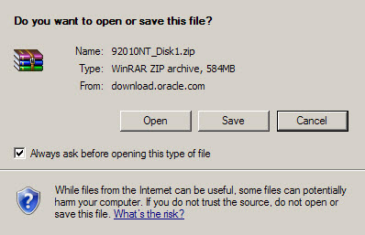

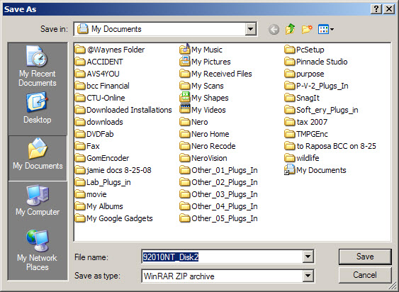

After you have downloaded all three files, you will need to decompress them into three unique directories – C:\Disk1 C:\Disk2 and C:\Disk3.
Base hard drive directories should be used so that the install application knows where to find the files. Simplest way to do this is to click on downloaded file names, one at a time.

This will open the window for WinRar or WinZip.
Click the extract button on the menu and key in C:\Disk1 for the destination folder – you should not need to change any other options. Do this for each of the downloaded files. Closing the extraction after each has completed.

Click on Start - lower left on your quick launch toolbar or desktop.
And then click “Run…”
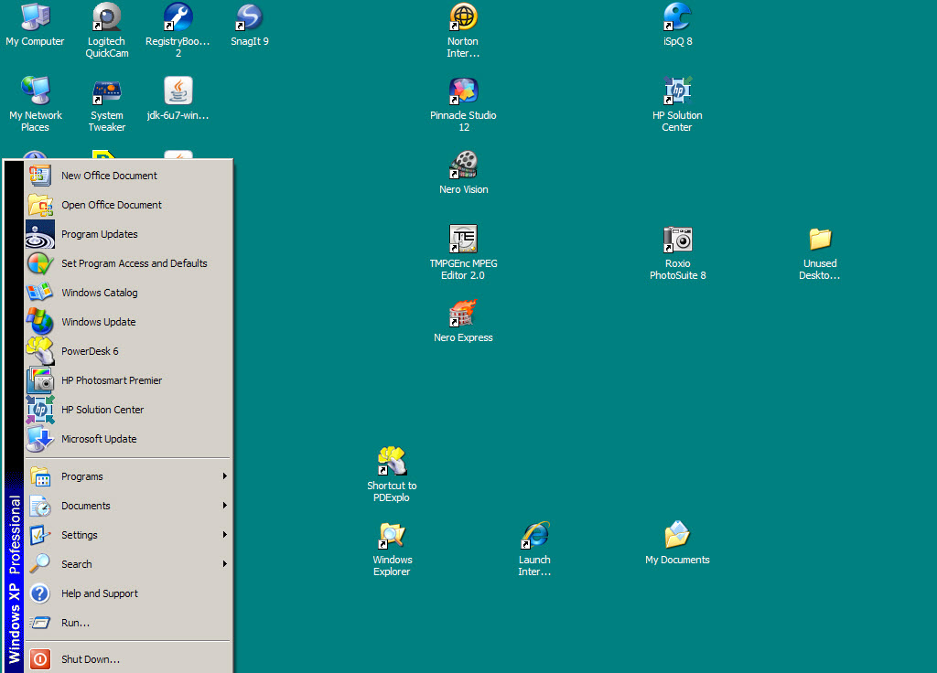

In the Open box, type in C:\Disk1\setup.exe and then the Okay button.

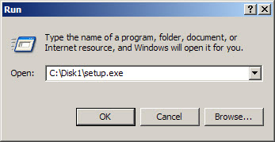

The oracle installer will start.

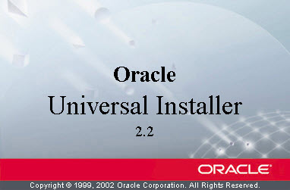

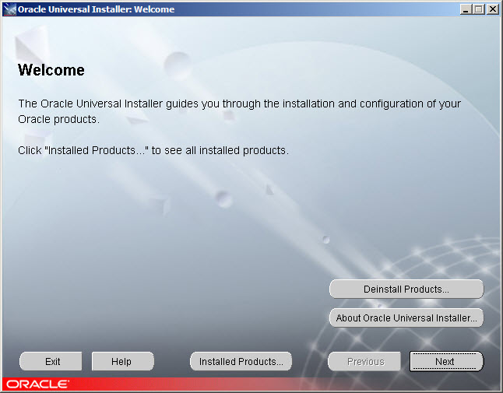

Click Next. And then you can select all of pieces parts that you want to install.
I pretty much installed everything. This will take a fair amount of time.
I did not follow through beyond this point with screen shots since to get them I would have to go through the rest of the install.
I did select the general sample database, and when it gets to the point of the domain to select – I selected MYORACLE from the drop down box.

The installation will open multiple DOS/Command “black boxes” and you may get some firewall conflicts/alerts. I just allowed everything to do through telling the firewall to always allow access for the program causing the alert.

If you run into any snags, the Installer is fairly smart and the help button is there if you need it.

If some optional feature “hang”, the installer gives you the option to cancel them and it will go on to the next.

Once installed, you will be able to access Oracle from your programs menu.

Good luck!

Cliff Molt

