Oracle 11g – Installation
Download, Unzip, and Install Oracle 11g on Windows 7 and create a local database *** PLEASE NOTE: This is a heavy duty database program. It may slow down your PC ***
- Download Oracle free from their website. Note: You will need to accept the agreement terms and also create a free account on their website in order to download the file.

- Visit this link and select the appropriate version for your operating system (32-bit or 64-bit). Be sure to download both files (part 1 and part 2). http://www.oracle.com/technetwork/database/enterprise-edition/downloads/index.html

- Extract both zip files into the same folder.

- Begin the installation: *** Make sure you are logged in as the Local Administrator!!! *** Do NOT install as a regular user with administrative rights. Run Setup.exe inside the database folder.

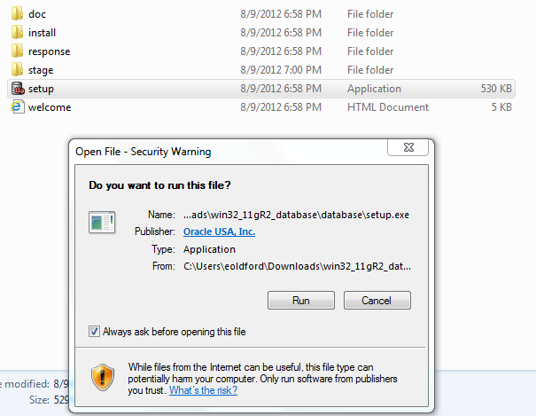

- Provide email information if you would like to receive security and software update notifications.
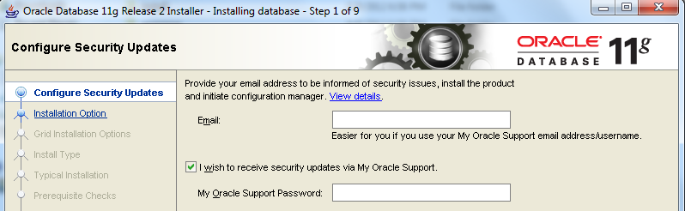

- Choose Create and configure a database
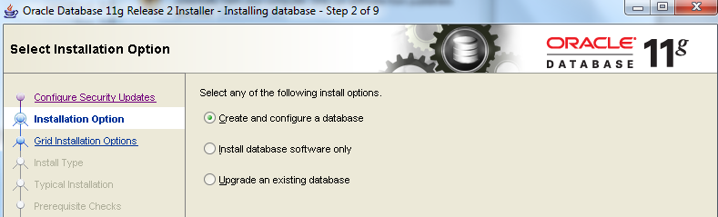
- Choose Desktop Class
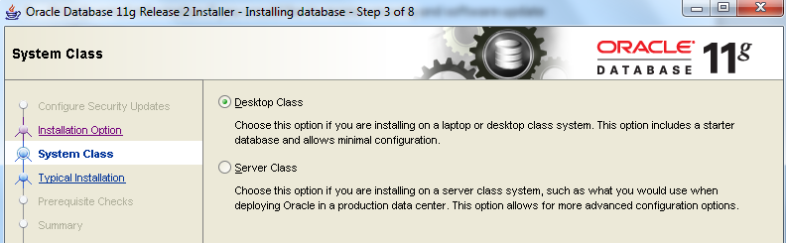

- Change the Base Directory to C:\Oracle. The software and database location will automatically change to be in the base folder. Select Enterprise Edition and Default Character Set. Setup a Database Name and Password. Write it down… you will need it!
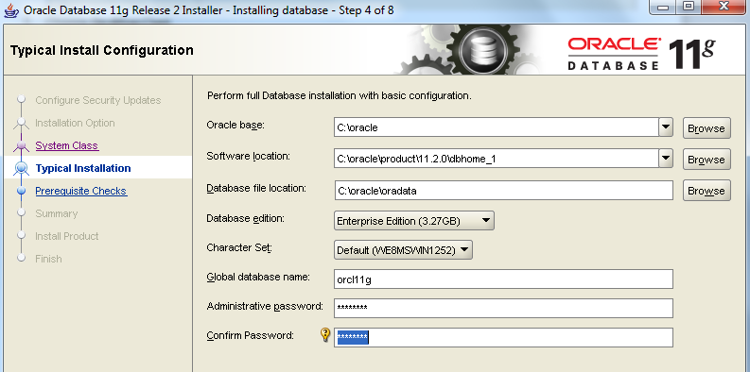

- Prerequisite checks are performed and a summary list is displayed. Click Finish to install.
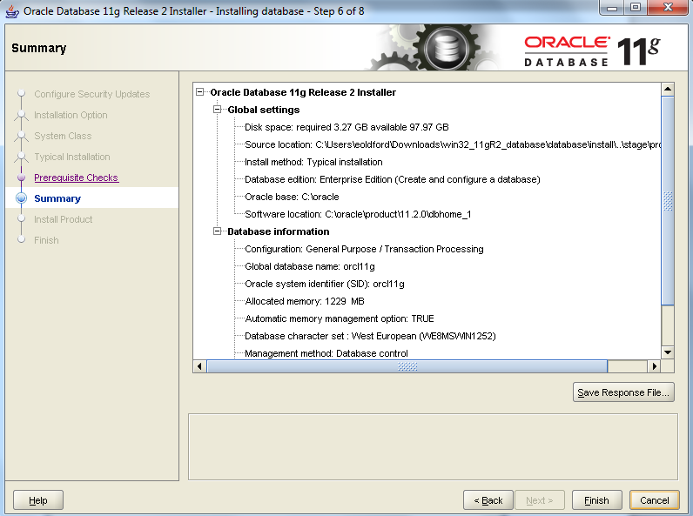
This process may take 20 minutes or more…
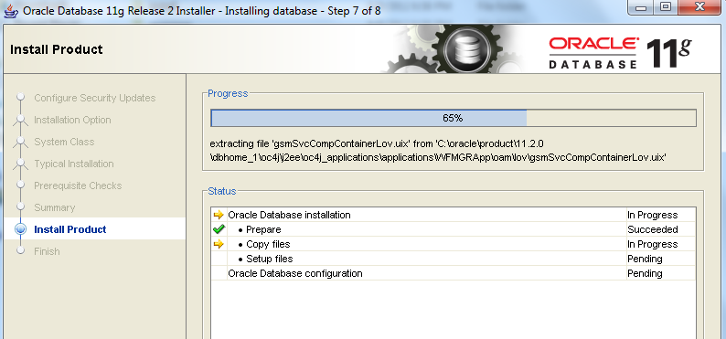
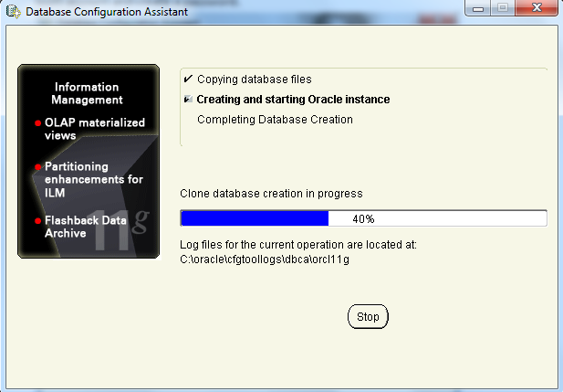

- When finished installing the database, Click the password management button to unlock the Scott account and create a password.
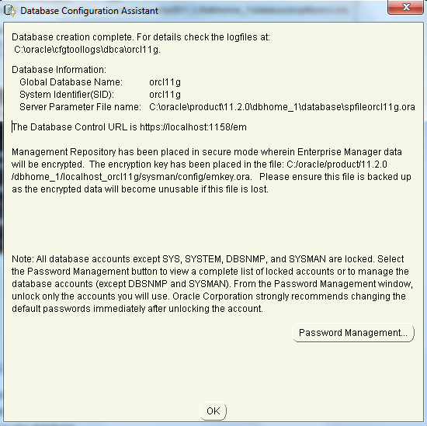
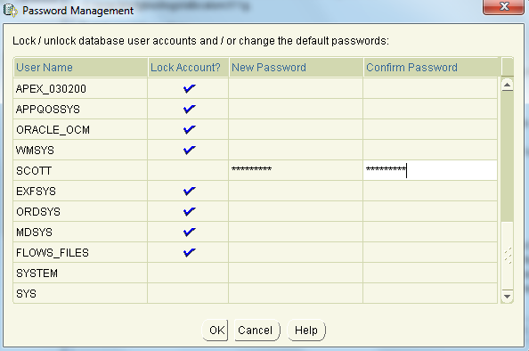

- To edit the users with the enterprise management tool:
Enterprise Manager Database Control URL - (orcl) :
https://localhost:1158/em
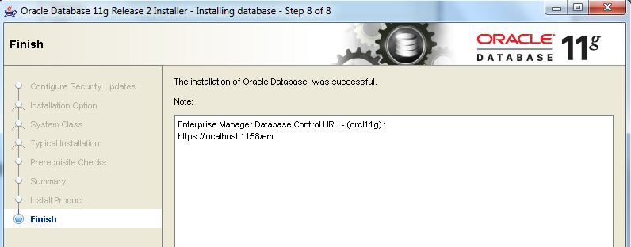

- *** IMPORTANT *** Make sure you change the permissions settings on the database folder to allow users to create and save tables.

Navigate to C:\oracle\product\11.2.0 and right-click properties.
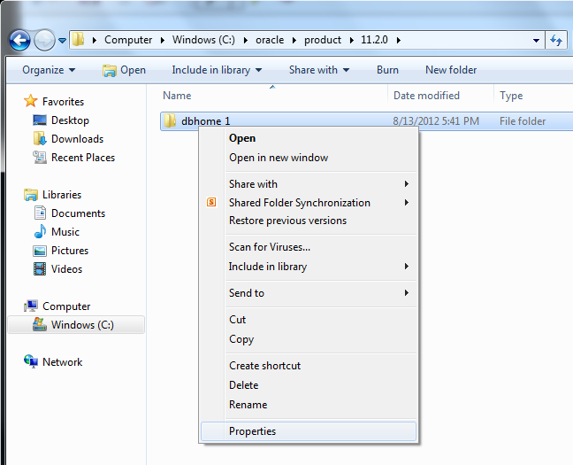

Click Security Tab, Select Authenticated Users, and Click Edit.
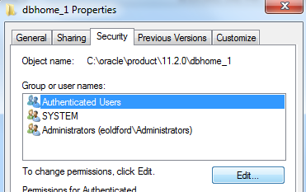

Click Allow Full Control and Apply.
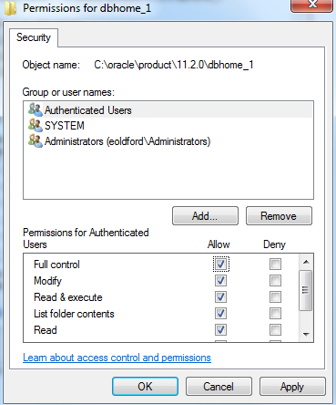

- As the local administrator, navigate to: C:\oracle\product\11.2.0\dbhome_1\network\admin and open sqlnet.ora with notepad. Change the Sqlnet.authentication_services= (NTS) to (NONE). This will allow regular local users to log in to sqlplus and access the database.
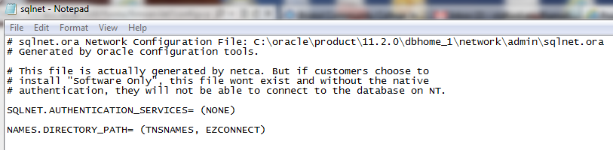

- Test installation – Log in to Sqlplus.exe. Open Start Menu
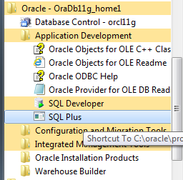

- Log in as scott and use the password you created.
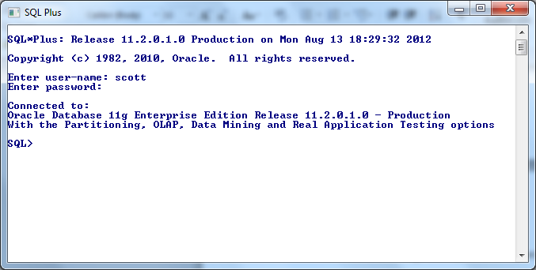
- To log into the administrative enterprise management console, use this link https://localhost:1158/em. Or, open the start menu, under the Oracle program group, open Database Control. Log in as SYS and Connect As SYSDBA. Use the password you set during the installation to log in. To edit users click the Server tab, under Security click Users.
