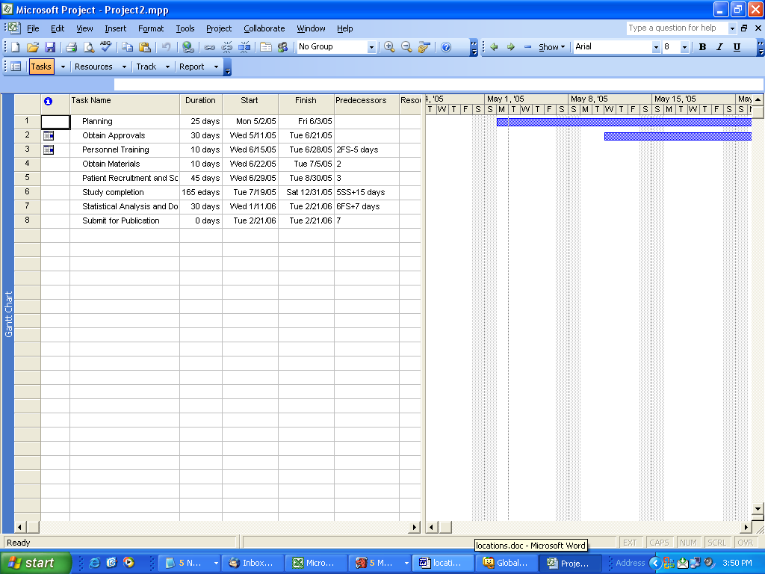
I followed the tutorial link under Project Manager at my web site (http://www.pgrocer.net/Cis54/cis54links.html) and created this sample.

Notice the predecessors entries that are explained in the tutorial and also notice their impact. Try to recreate this project to experiment with the project manager.

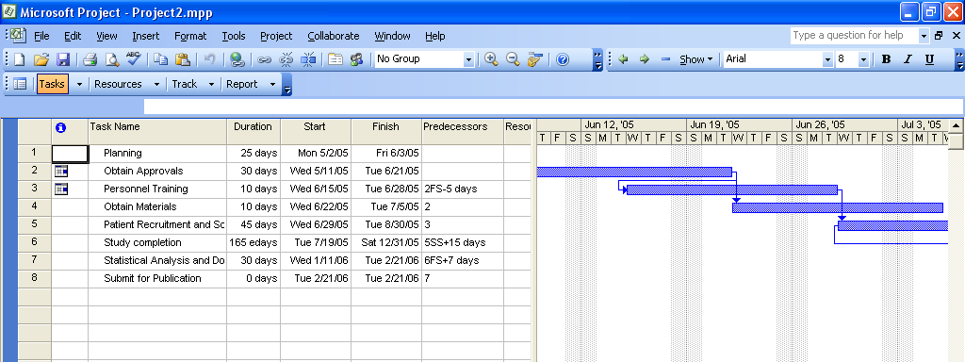

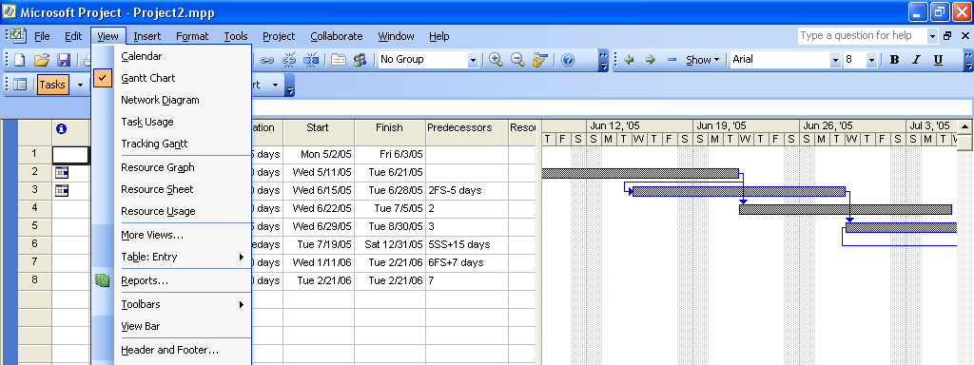
Now I am going to move from the Gantt chart view to the calendar view.

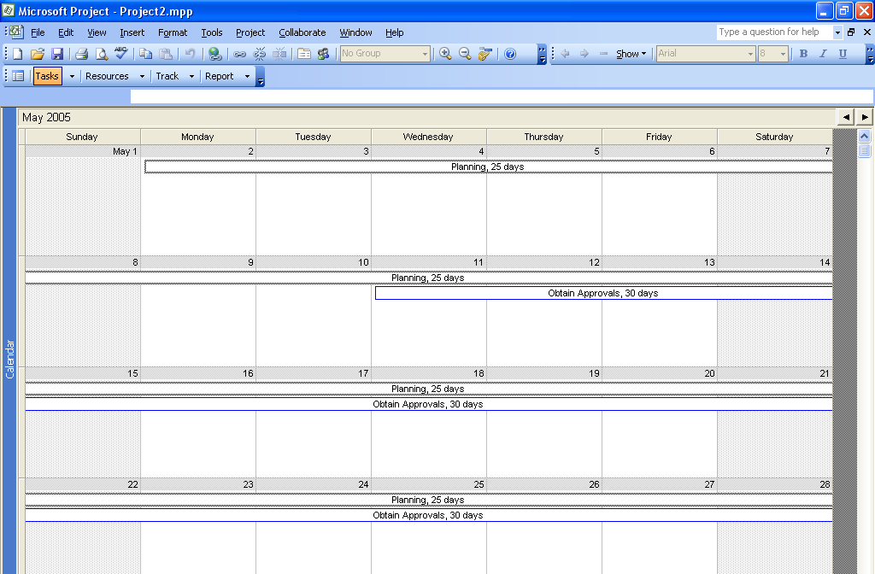

Now I am looking at the network diagram view.

