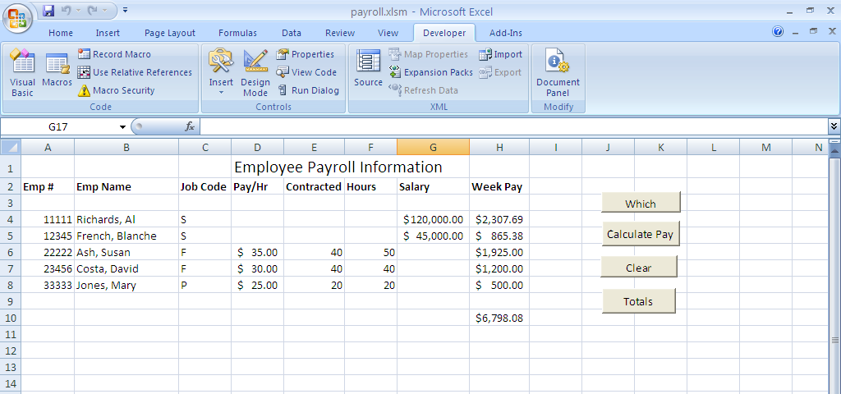

Private Sub cmdCalcPay_Click()
Dim theRow As Integer
Dim ovtHrs As Double
Dim ovtPay As Double
For theRow = 4 To 8
If Sheet1.Cells(theRow, 3) = "S" Then
Sheet1.Cells(theRow, 8) = Sheet1.Cells(theRow, 7) / 52
Else
ovtHrs = Sheet1.Cells(theRow, 6) - Sheet1.Cells(theRow, 5)
If ovtHrs > 0 Then
ovtPay = Sheet1.Cells(theRow, 4) * ovtHrs * 1.5
Sheet1.Cells(theRow, 8) = Sheet1.Cells(theRow, 5) * Sheet1.Cells(theRow, 4) + ovtPay
Else
Sheet1.Cells(theRow, 8) = Sheet1.Cells(theRow, 5) * Sheet1.Cells(theRow, 4)
End If
End If
Next theRow
End Sub

Private Sub cmdClear_Click()
Dim theRow As Integer
For theRow = 4 To 8
Sheet1.Cells(theRow, 8) = ""
Next theRow
End Sub

Private Sub cmdTotals_Click()
Dim theRow As Integer
Dim theTotal As Double
For theRow = 4 To 8
theTotal = theTotal + Sheet1.Cells(theRow, 8)
Next theRow
Sheet1.Cells(10, 8) = theTotal
End Sub

Private Sub cmdWhich_Click()
Dim theRow As Integer
For theRow = 4 To 8
If Sheet1.Cells(theRow, 3) = "S" Then
MsgBox ("Salaried")
Else
MsgBox ("Hourly")
End If
Next theRow
End Sub

