This is a testing using database books09.accdb with Visual Basic 2008:
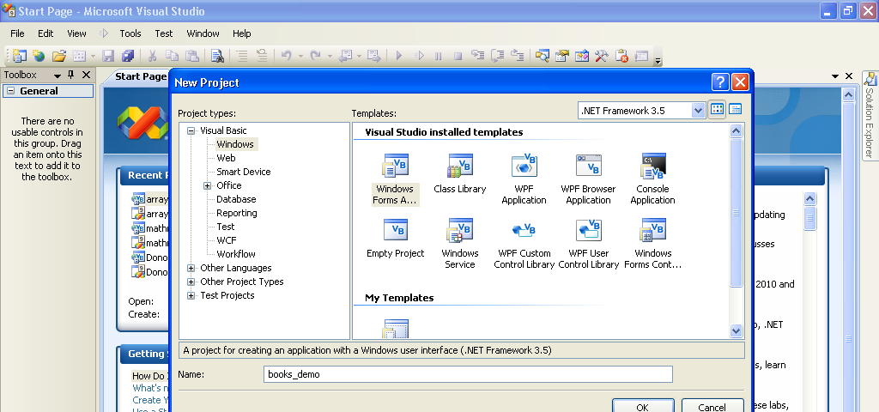
I am naming the project books_demo. Now I am going to save it using Save All.
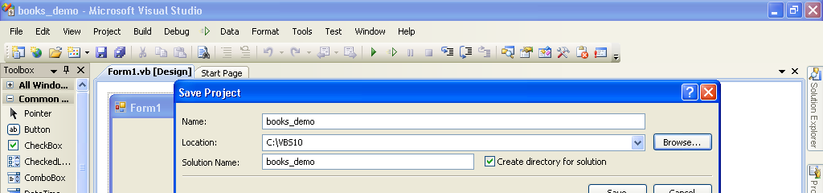
The next thing I will do is add in a data source, but before I do that I will show you the file structure.
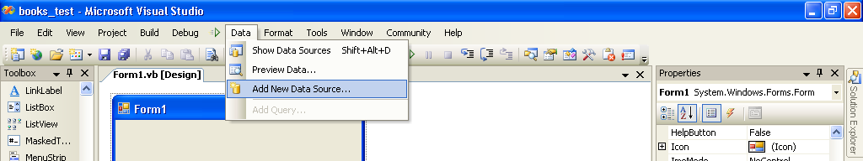
I am using a database called books09.accdb This is a layout of the structure.
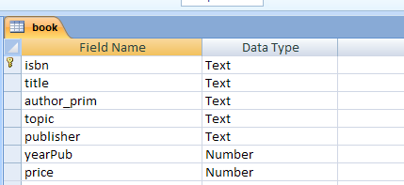
Now I will continue by clicking on the Add New Data Source shown above.
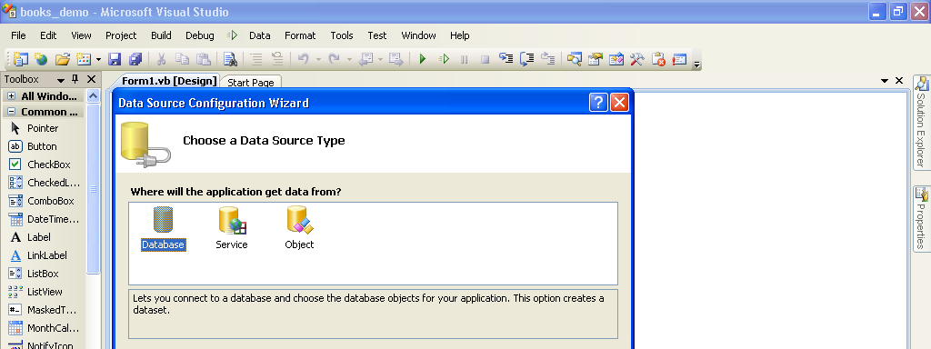
I am selecting database and then I will click next at the bottom of the screen.
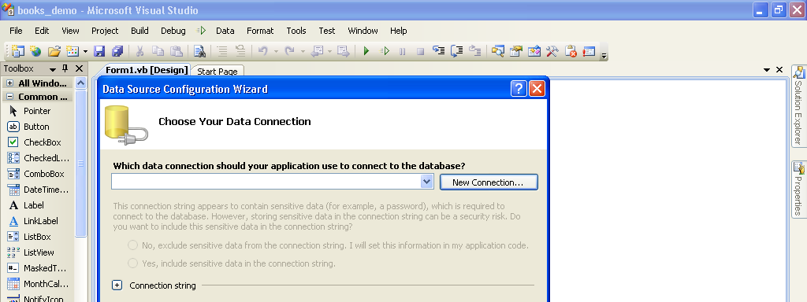
Now I will click on New Connection and select my database.
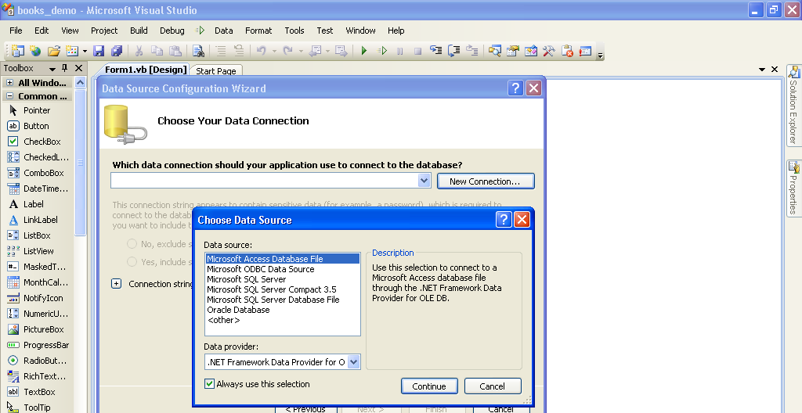
First I select Access since this is what I am using and next I will browse for the database.
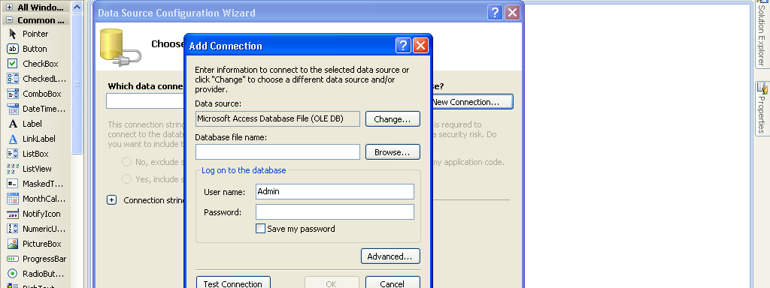
After I locate the database, I test the connection.
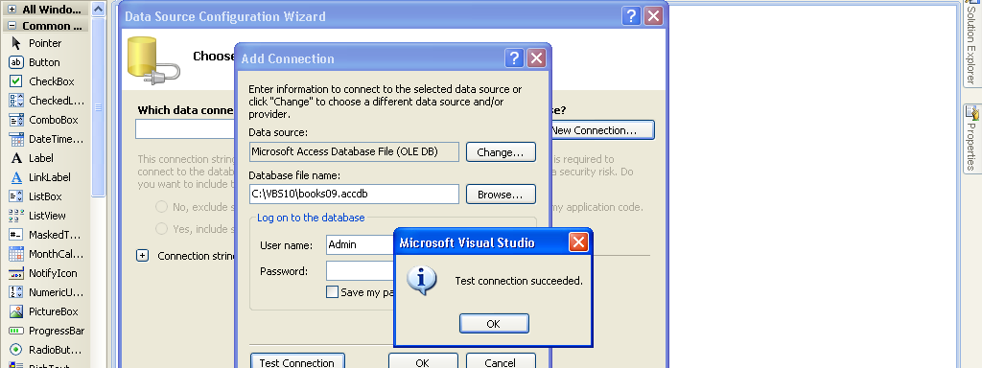
I am returned to the connection screen and click on next.
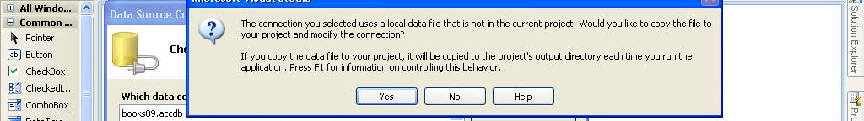
Now I am clicking on yes to put the database in the project.
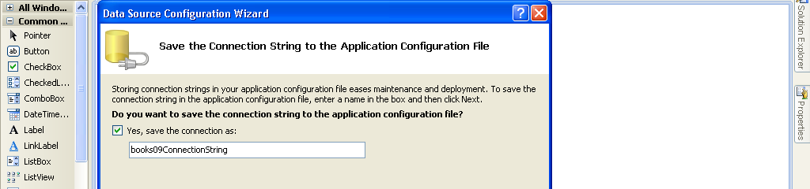
I clicked on next.
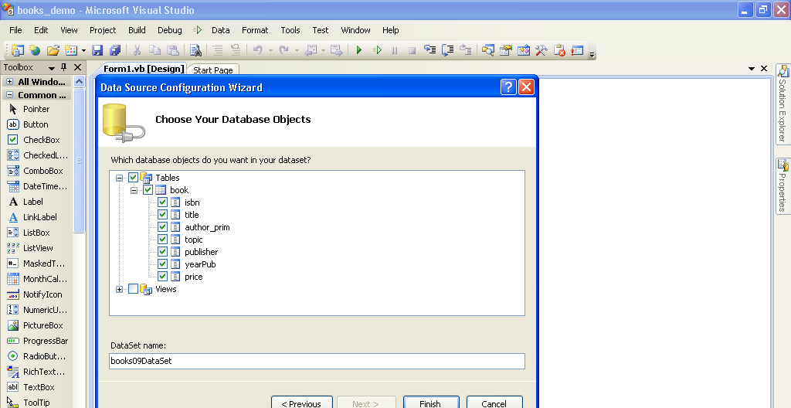
This came up with Tables with a + in front, I clicked on the plus to see the tables (there is only one and it is named book), I clicked again to see the fields and then I checked book to make it available in the dataset and then clicked Finish.
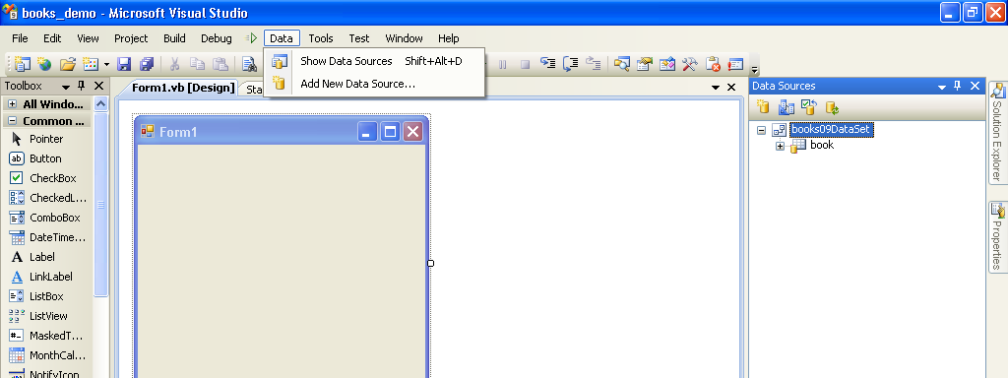
Now I clicked on show data sources to see the data that is available.

Now it is time to start creating the form. If I click on the plus in front of book, I will see the fields available on that table. In the screen below, I then clicked on isbn and dragged it over to the form.
Note the objects that are now involved and the navigation bar that is placed on the form.
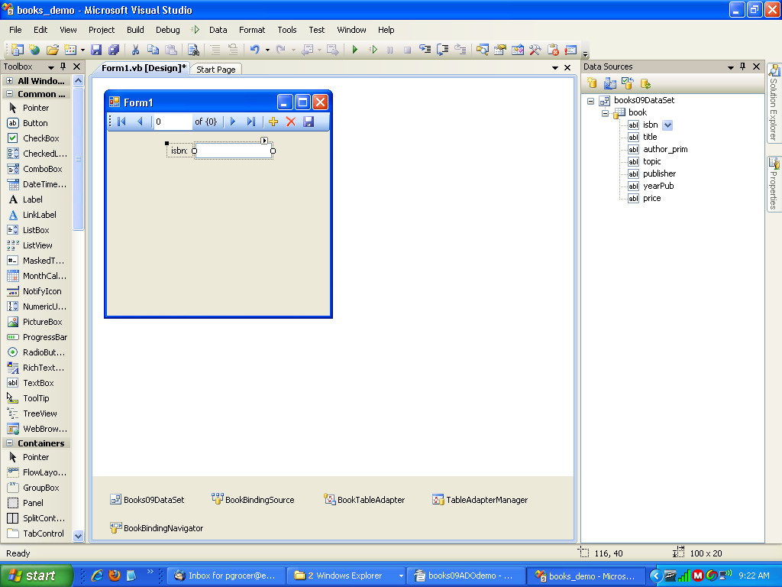
Now I am going to run with just this one field.
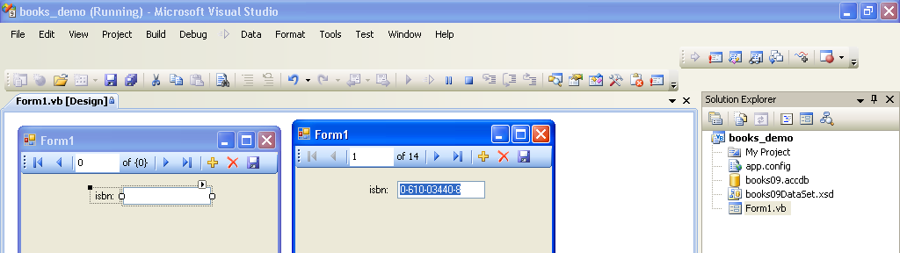
If I use the navigate bar, I can move through the records on the table.

Note, if I drag over the whole table as opposed to individual fields, it makes a grid.
