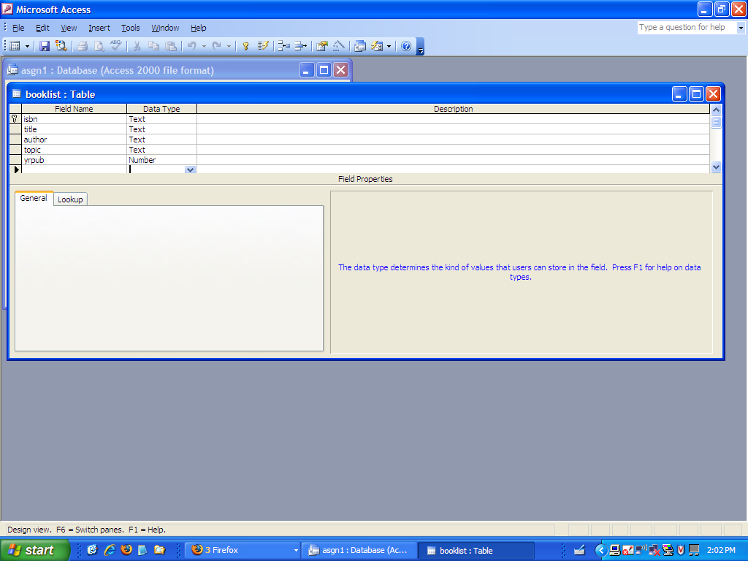
This is a description of the table – below is the data.
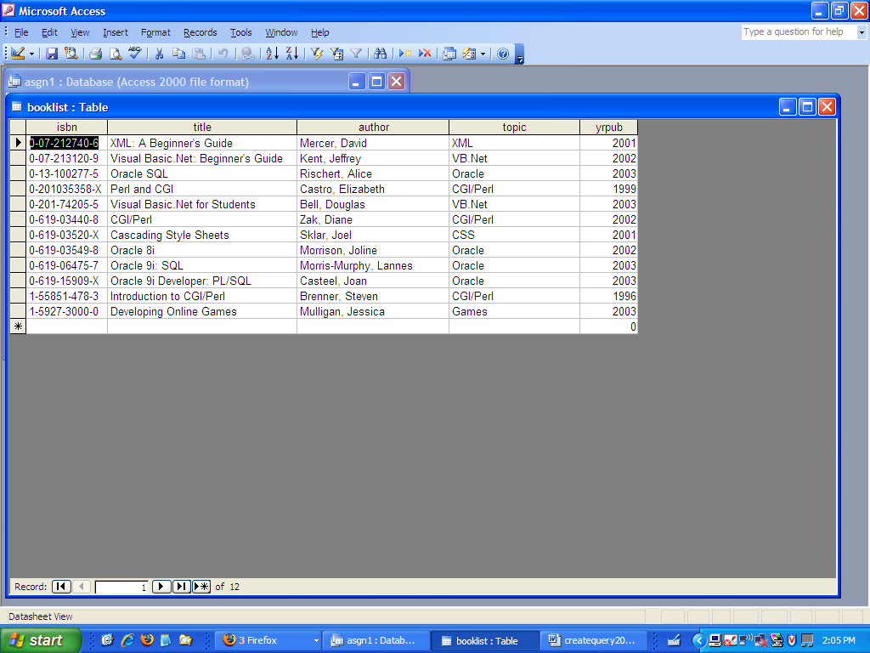
Now I am going to do a query. Note that I already have some queries there. First I click on queries (gets me into the query area) and then I click on new to make a new query
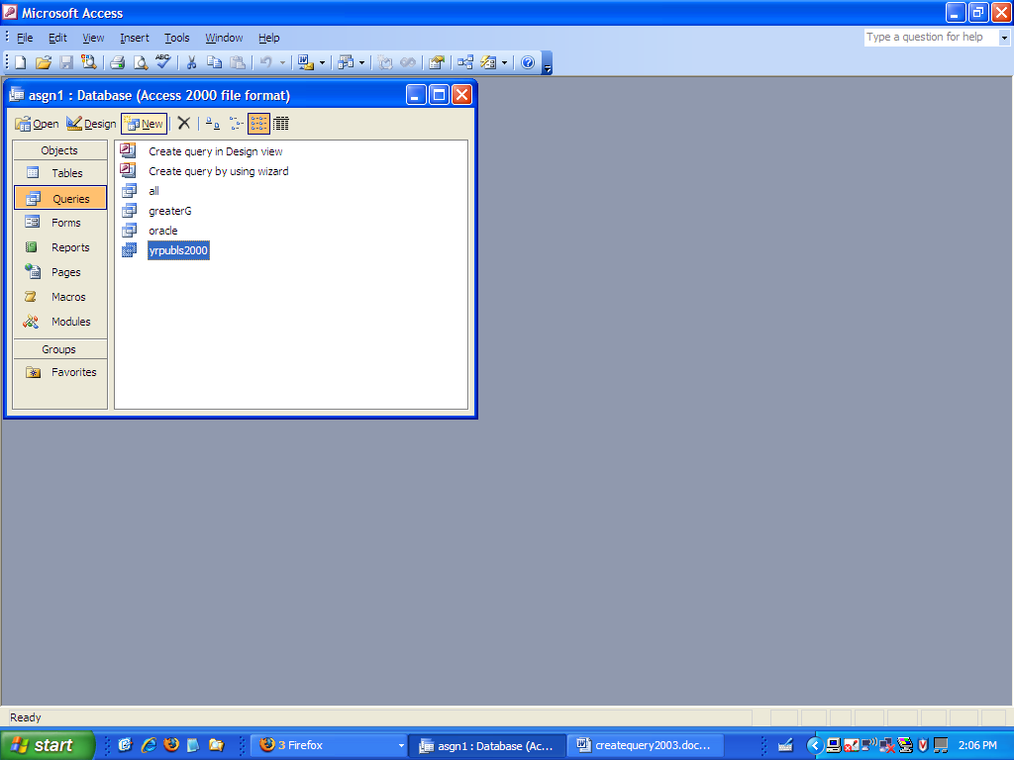
Next, I select design view from the New Query window that comes up.

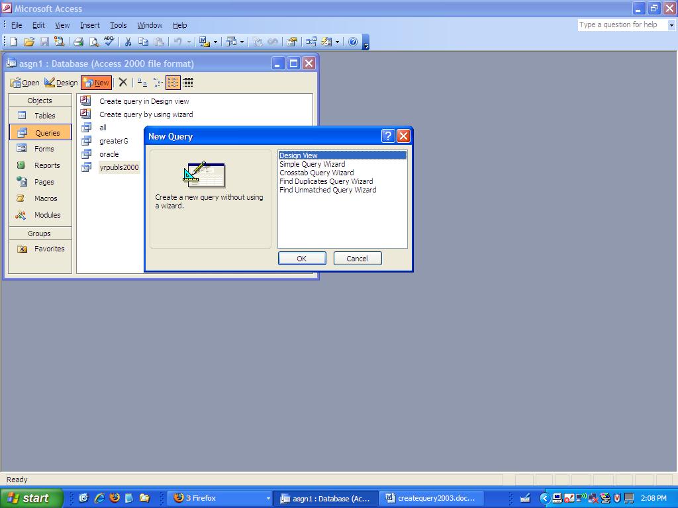
The next screen lets me start to make the query. I will need to select the table or tables that I want to use. Since the sample that I am using only has one table, there is only one table listed in the Show Table. I click on Add to add it to the query. When the table is there, I click on close.
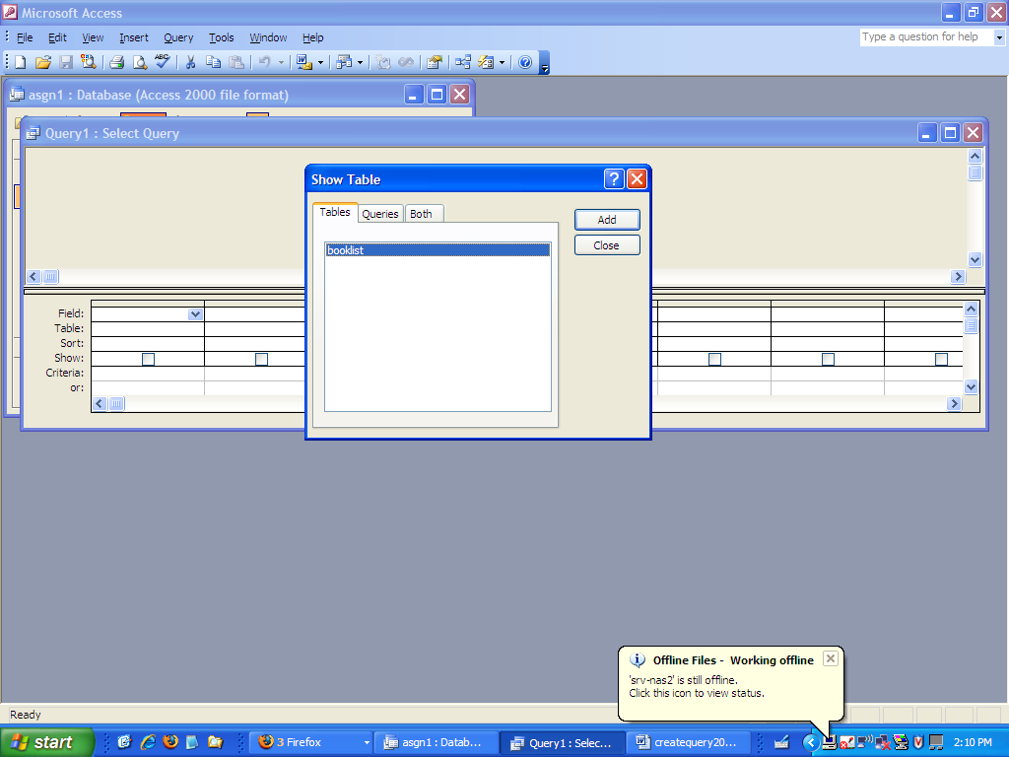
The shot below shows the table in the query.
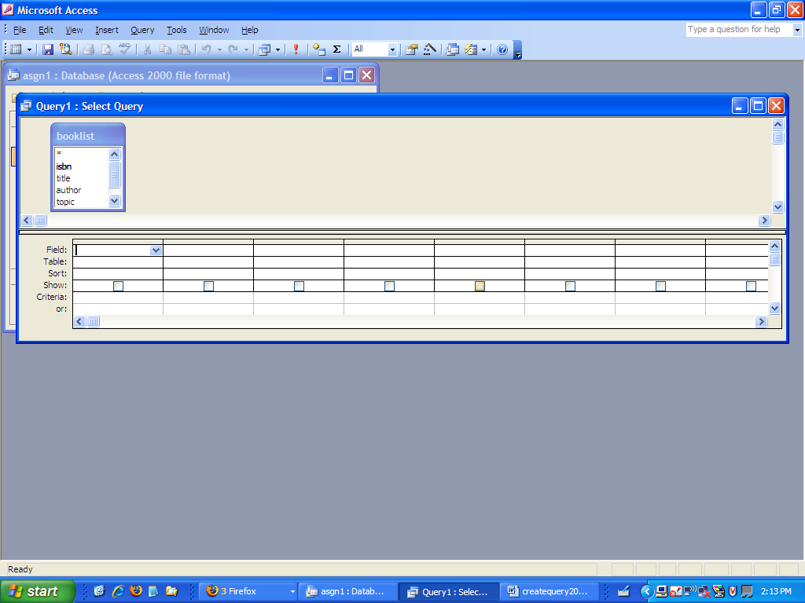
Now I can click on fields in the booklist or drag them down or click on the arrow beside fields to see the fields and select one. Note that I can set up the query with one or many fields. In the screen below, I brought down everything but topic.
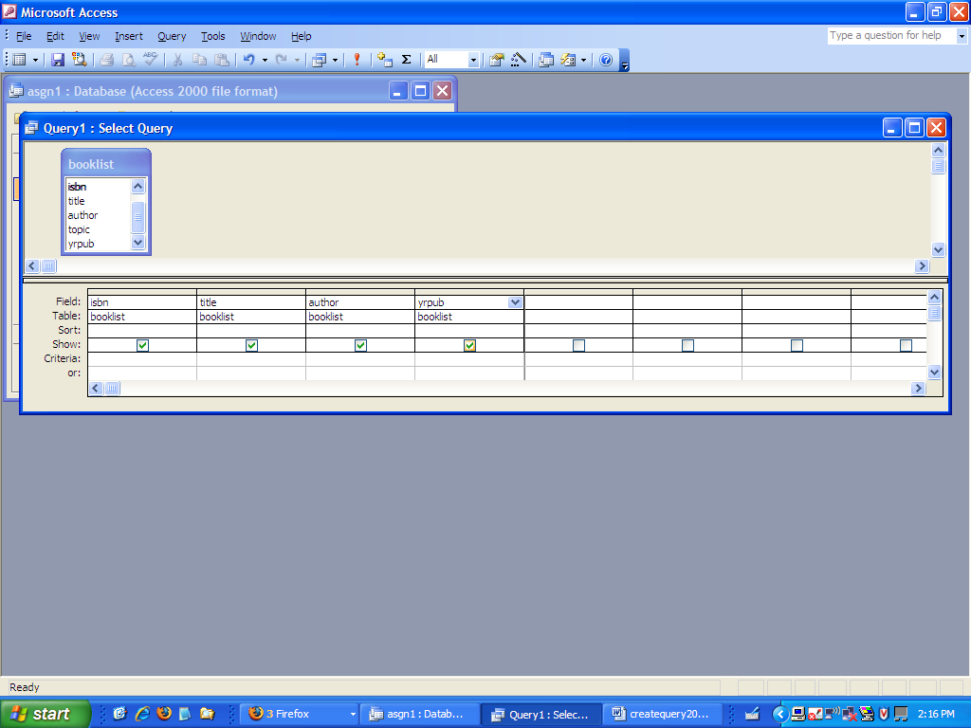
Now if I click on the icon right below file in the icon line, I will see the results of the query.
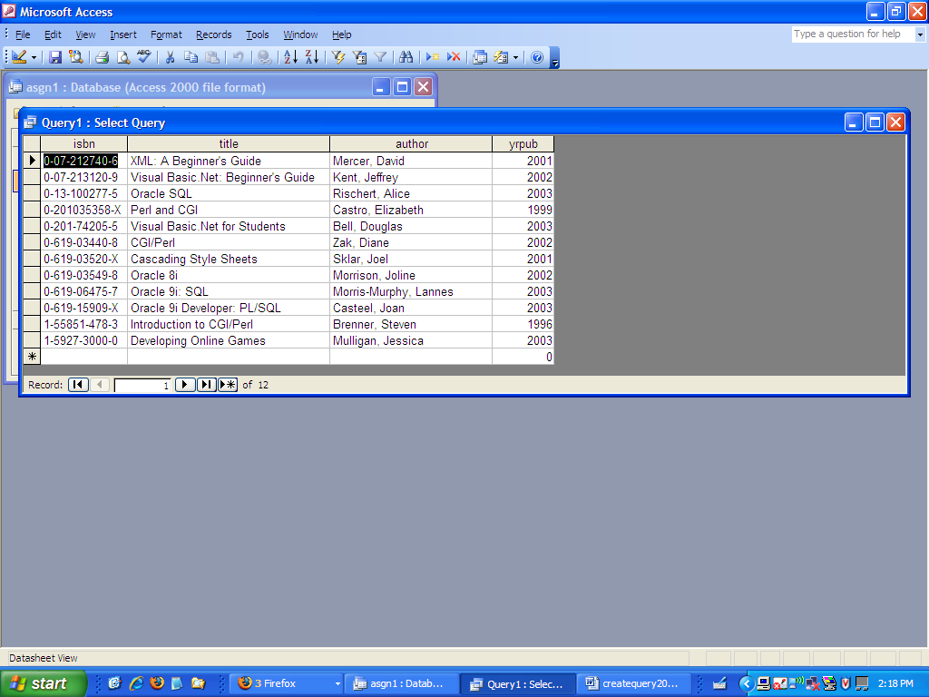
Now I click on the icon right below file again to go back into design mode because I want to change the query. I am asking to see all records where the yrpub is 2002. You can see that the 2002 is in the criteria row under the yrpub column. Right below I show the results gotten by clicking on the design icon.
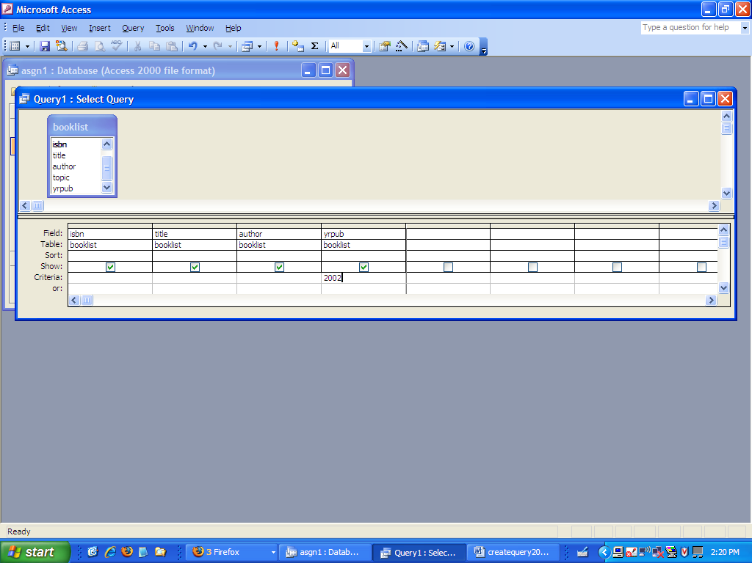
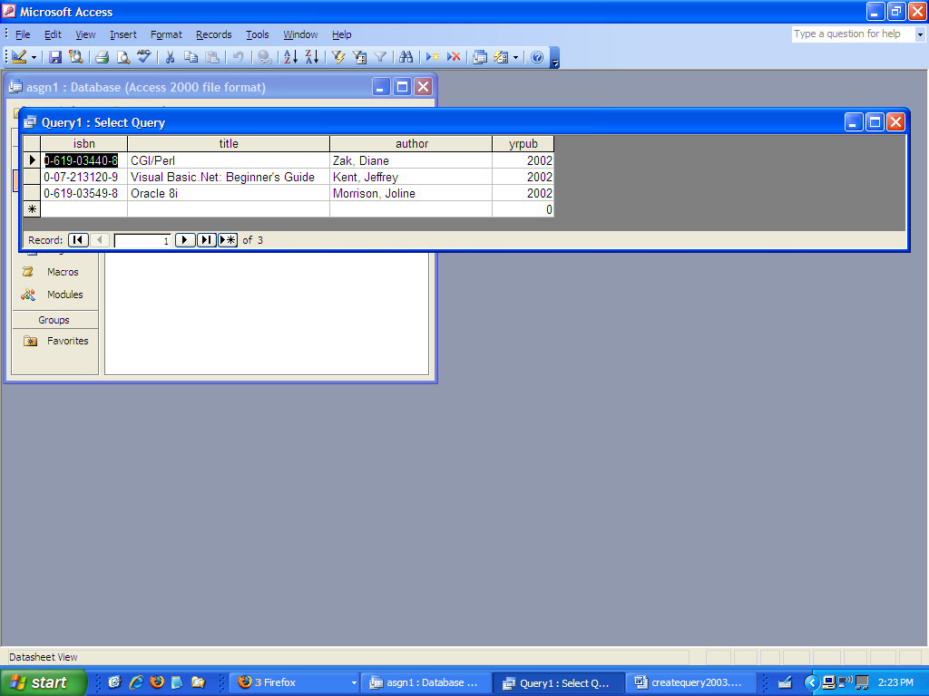
When I want to save, I can click on the X box in the far right corner of the query and I will be prompted to save. I then enter a name for the query.
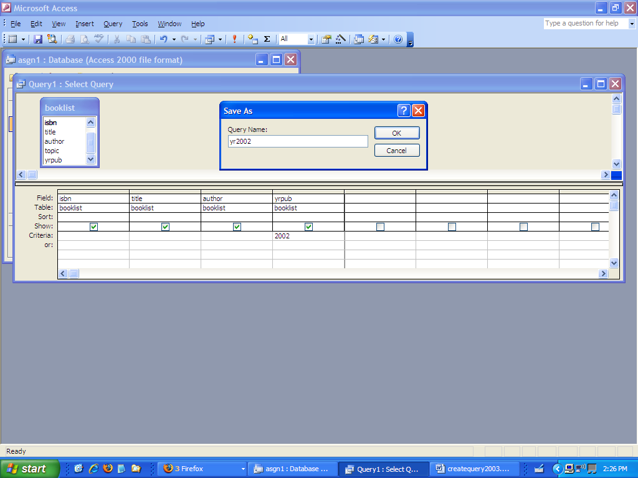
I have started a new query using all five fields. Now I have two criteria in an AND relationship. I want the topic to be Oracle and the year > 2002. Note that Oracle is in quotes because it is a string/text field and the year is not because it is a numeric field.
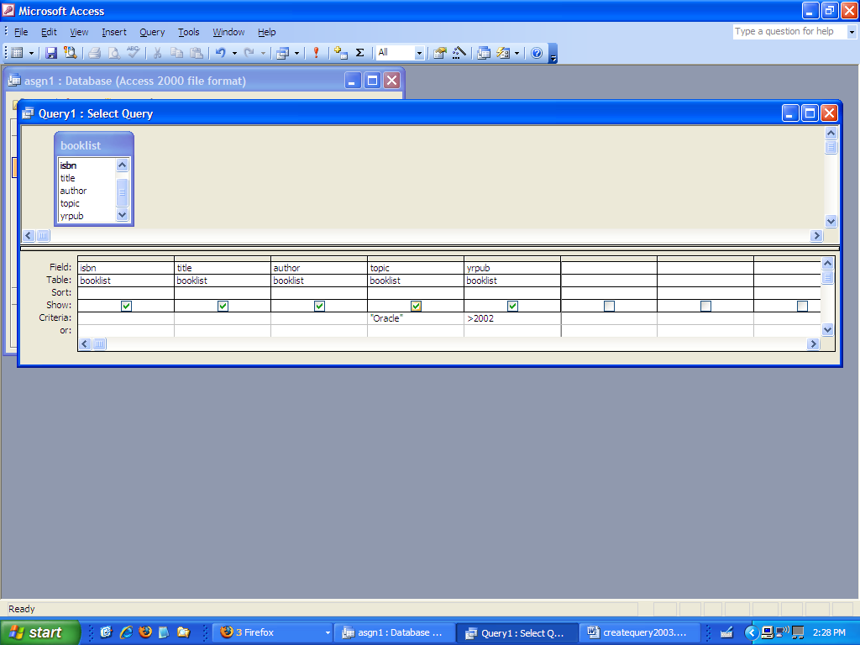
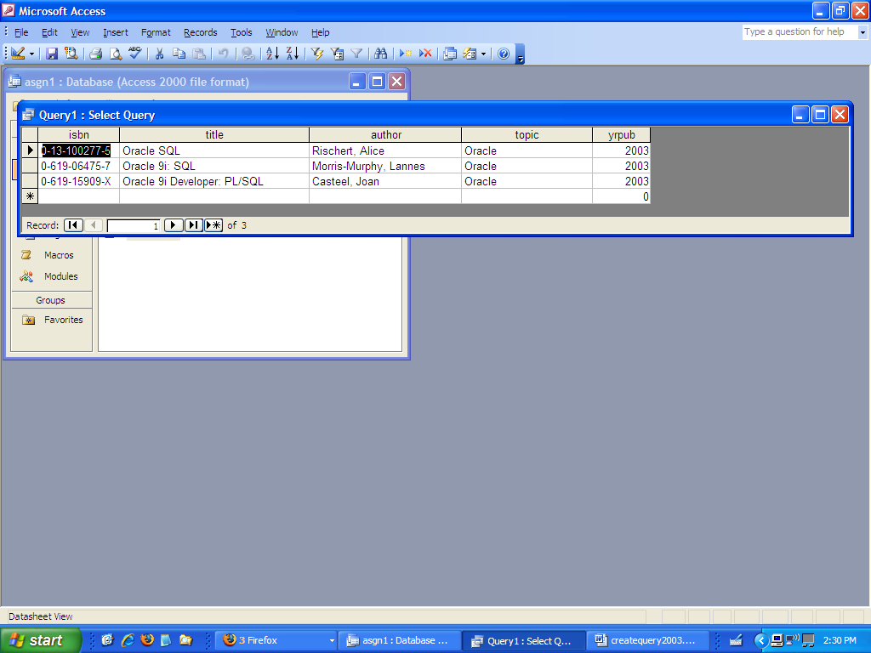
If I want an OR relationship, I put one in the criteria line and one in the or line.
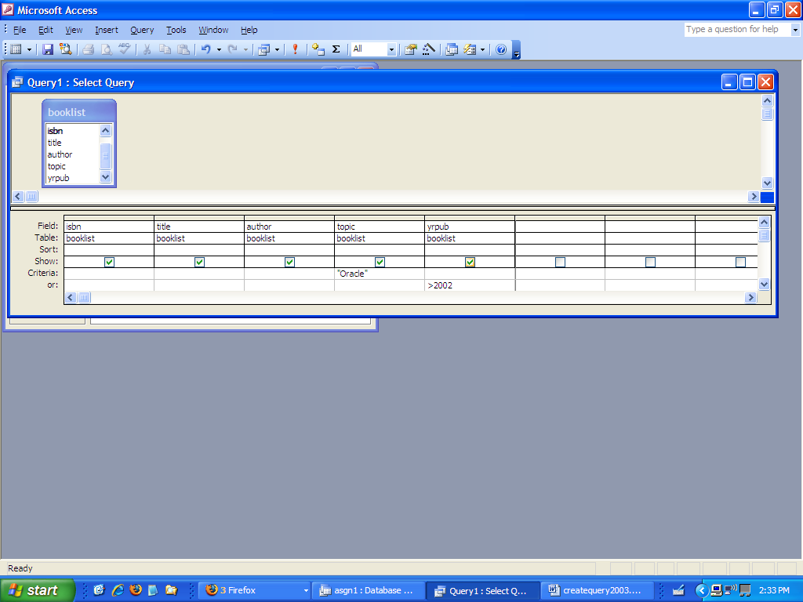
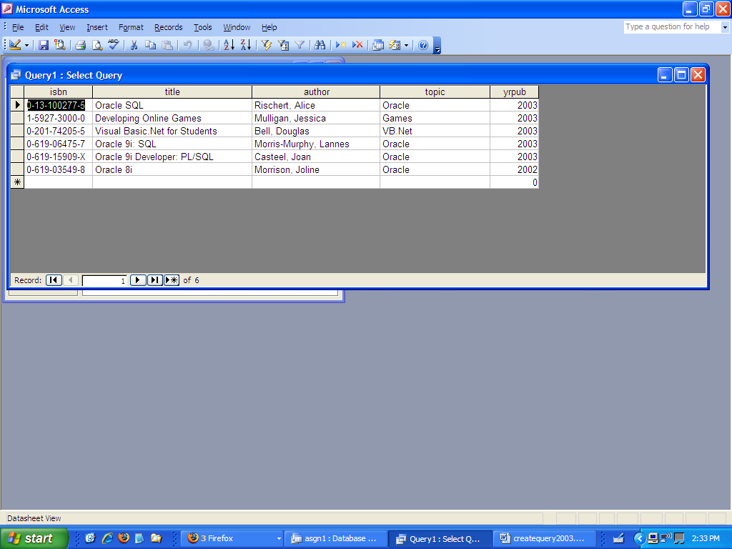
The next one is showing one thing that has to be true and then I want either of two other things to be true. So I want the yrpub > 2000 and either the topic Oracle or the author name > “M”. Note that when you want something to always be true, it appears on both the criteria line and the or line.
