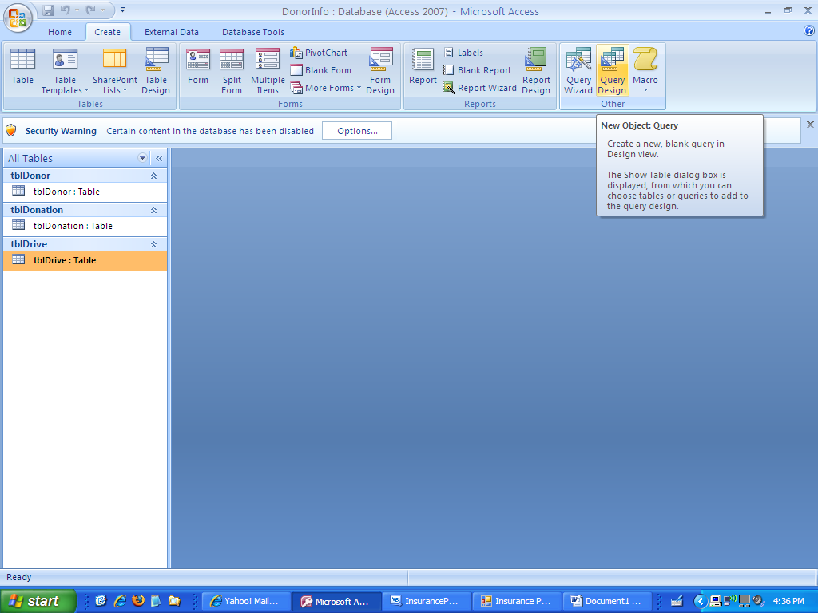
To create a query, click on create and then click on query design.
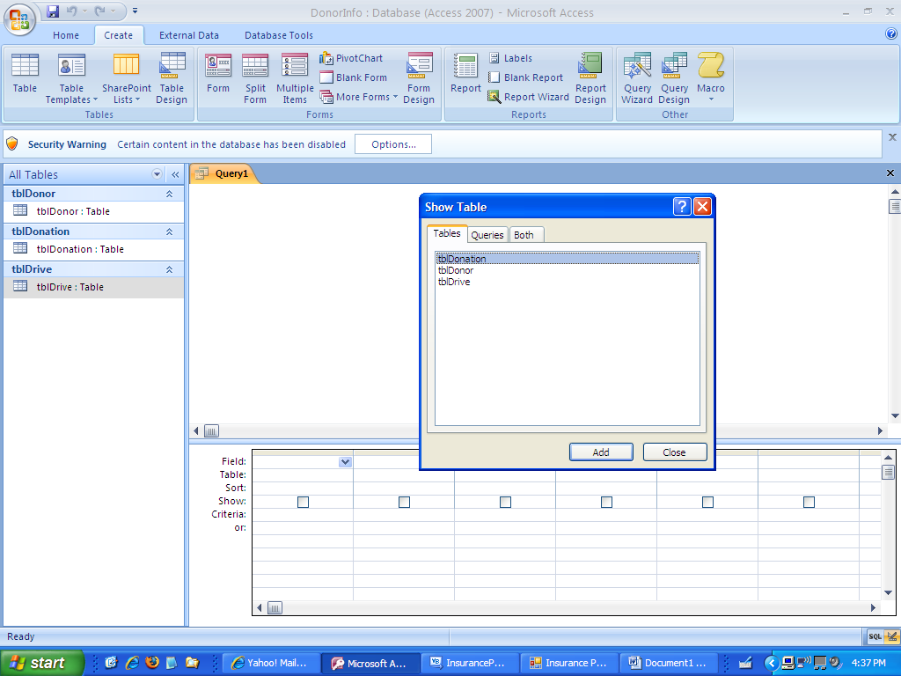
This screen should come up. Since you are only using one table there will only be one table in the list. Click on that table. I am going to click on the donor table that I have called tblDonor. When the table is up there, I will close the show table box.
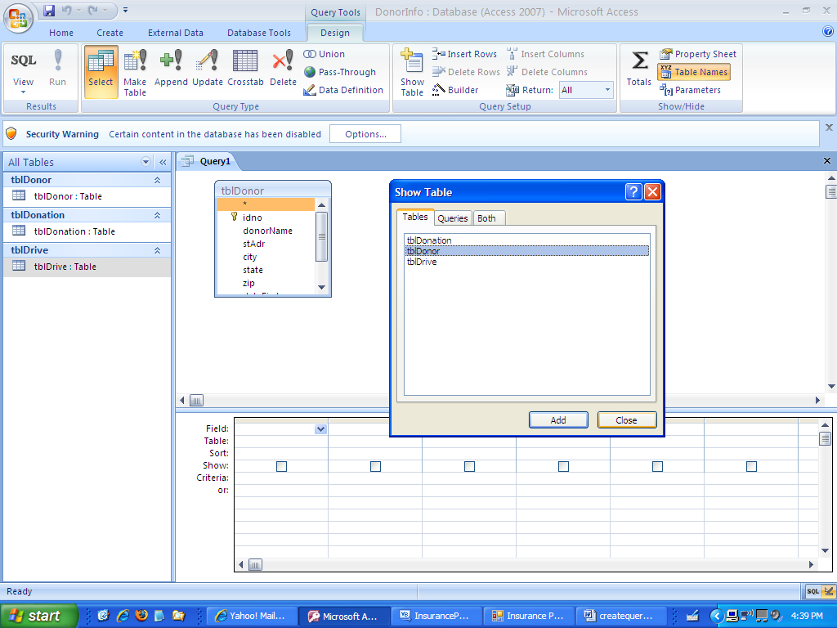
This shows the table. Now on the screen below, I double clicked on the fields that I want in the query.
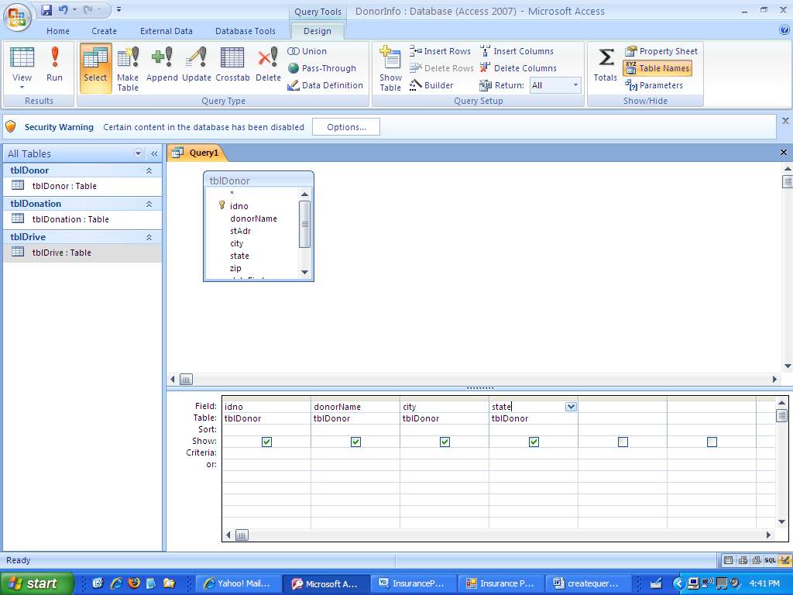
Now that the fields are there, I can see the results of the query by clicking on view.
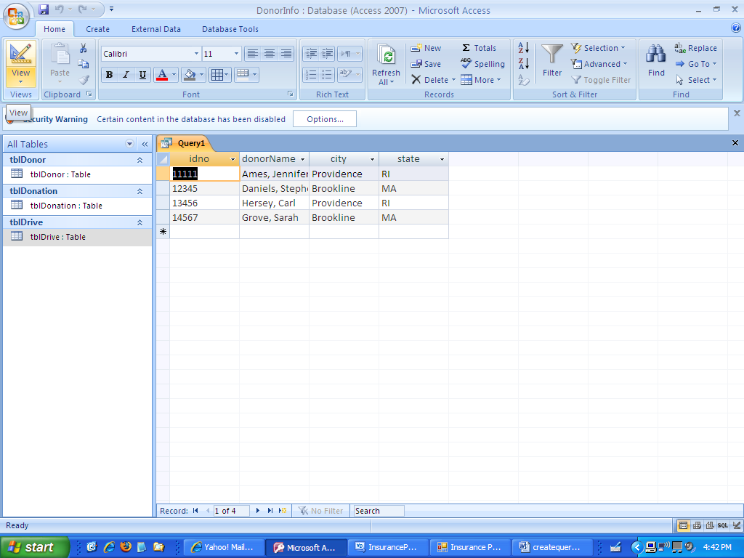
When I want to go back to designer view, I click again on the view with the pencil etc.
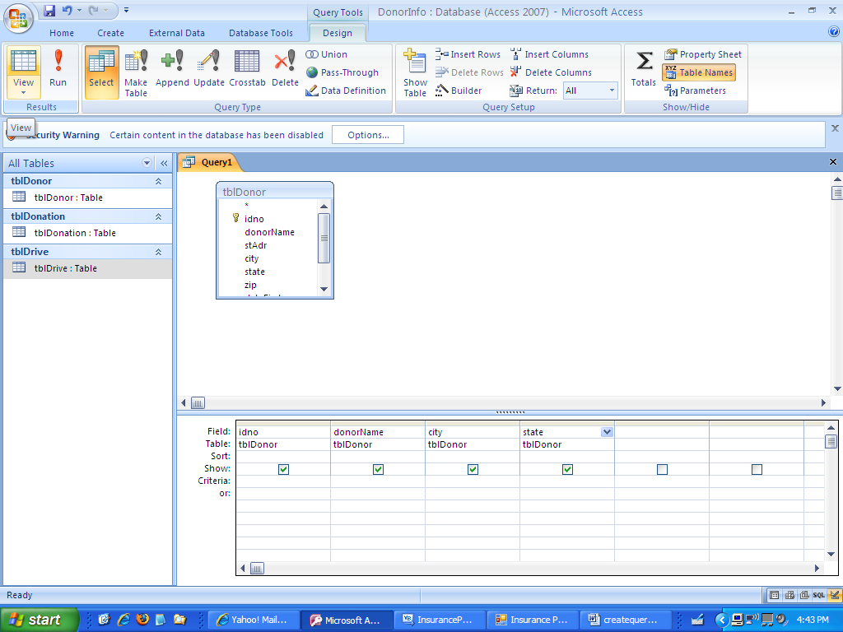
Now I only want to see records with a criteria of MA so I make an entry in criteria under the state column.
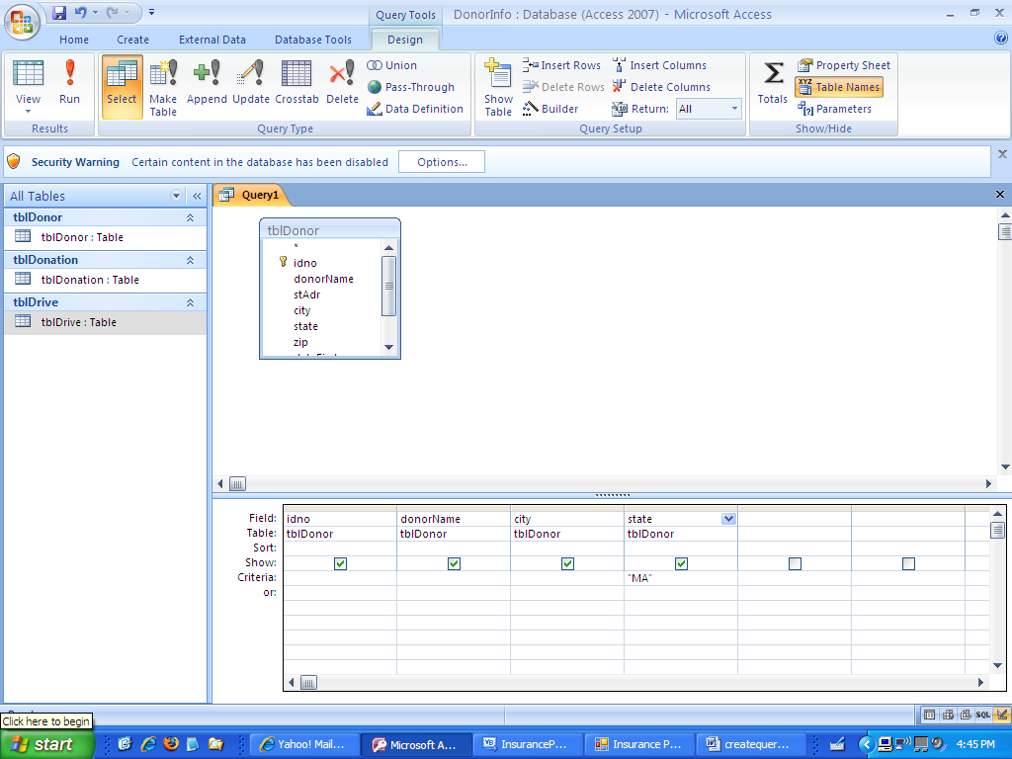
The screen below shows the results.
