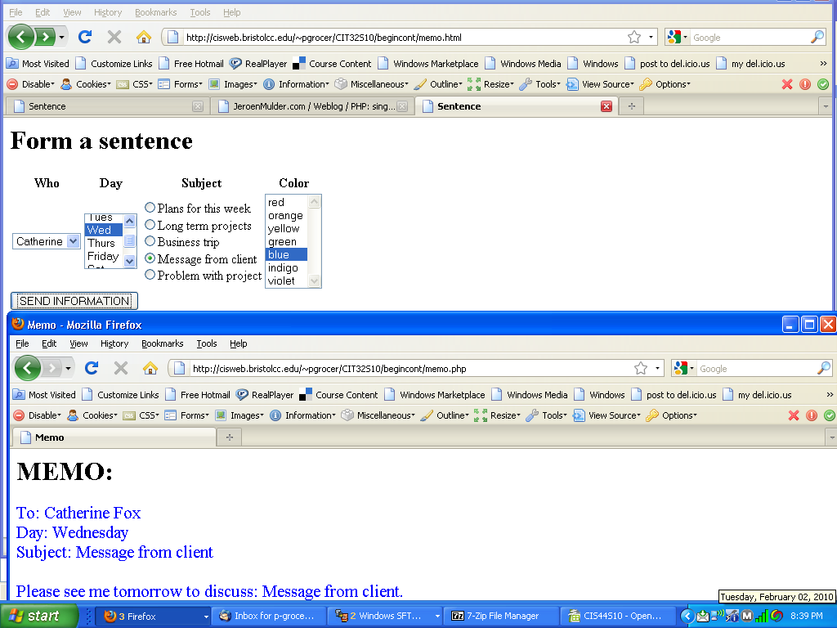
Please write these the memo.html and memo.php to produce these results.

