Using MySQL:

A table without a key.

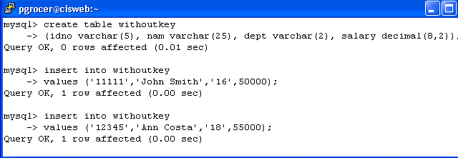
Now I am going to add a primary key.

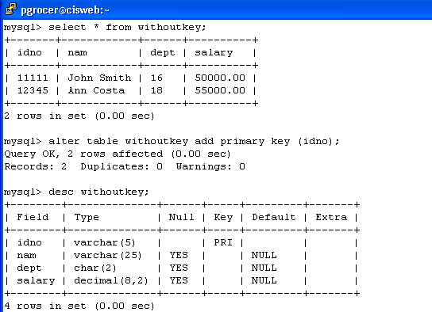

Now I am creating an index on dept:
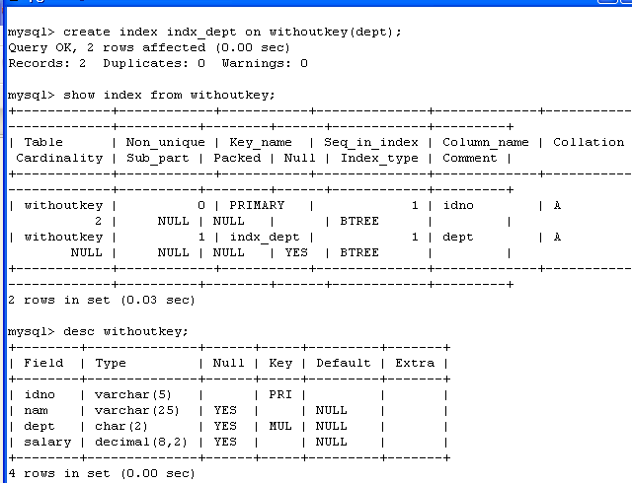

Now I am going to drop the index and then drop the primary key.
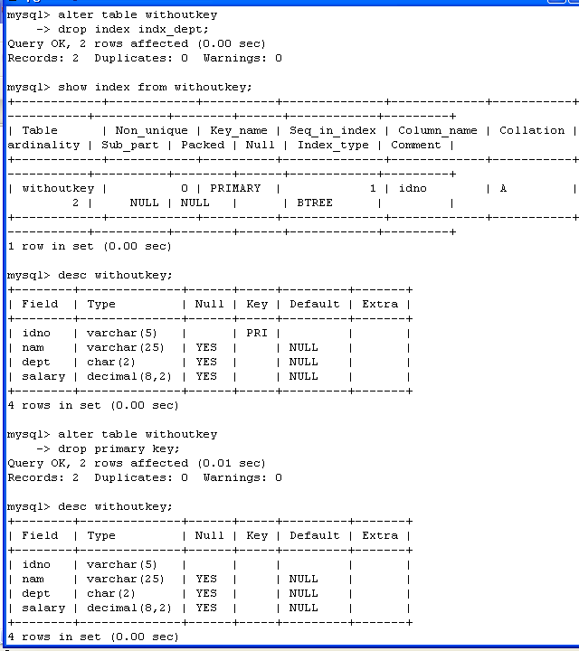

Making a three part primary key on an existing table.

