Subqueries in MySQL:

A simple subquery using two tables: In this example I want all the donations for Animal Home. Let's say, I do not know the driveno for Animal Home. I can do a inner select to get the driveno and then do the outer select to get all the donations with that driveno. Below the example, I will do the selects individually.

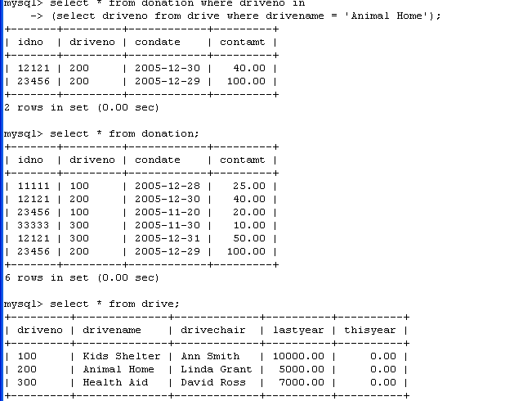
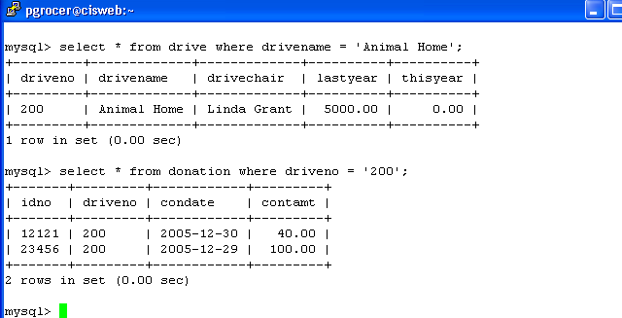

This example uses the same table for the outer query and the inner query:

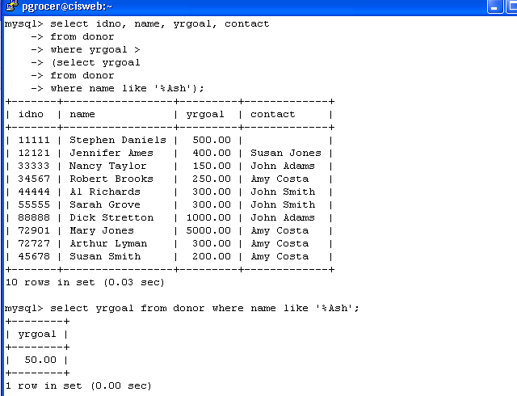
I want to find out what the year goal is for someone with the last name of Ash. Once I find that out, I want to display everyone that has a year goal greater than the year goal of Ash. Notice the structure: the inner select is retrieving a yrgoal and the outer select is testing against yrgoal.
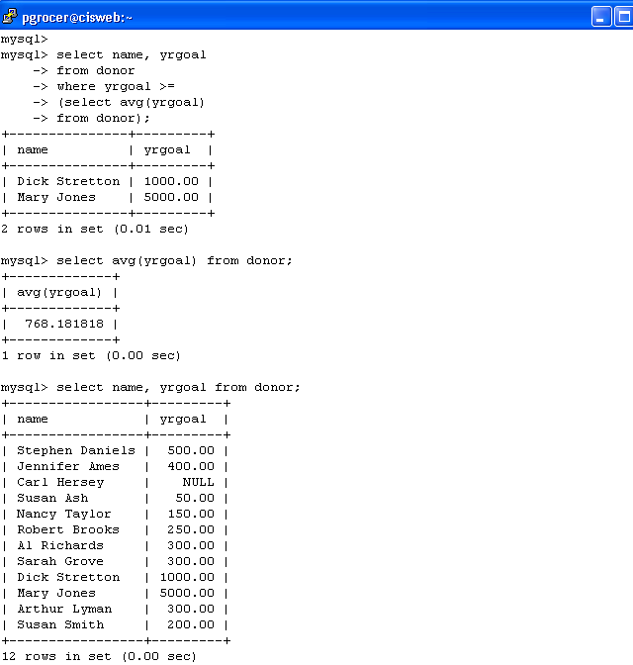
The inner select finds the average yrgoal from the donor file and then the outer select finds all donors where the yrgoal is greater than or equal to the average. Again the inner select is returning the average for yrgoal and the outer select is testing against yrgoal.

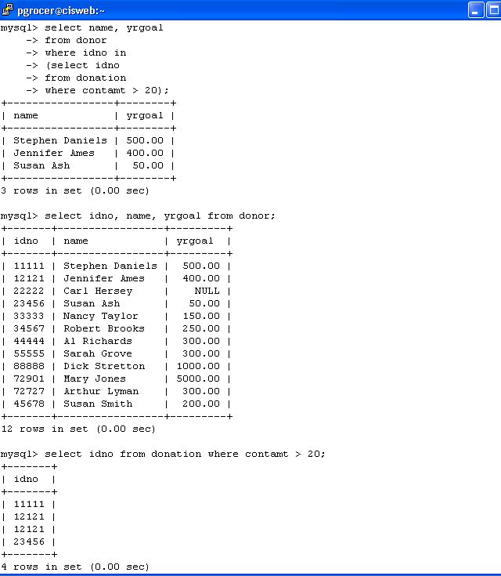
I am using two tables. I am using the inner select to look at the donation table and select all idno where the contamt is greater than 20. The outer select than prints the name and yrgoal from the donor table for those donors that were selected by the inner select. Again, the inner select is coming up with one or more idno and the outer select is testing for a idno in the list that was retrieved.

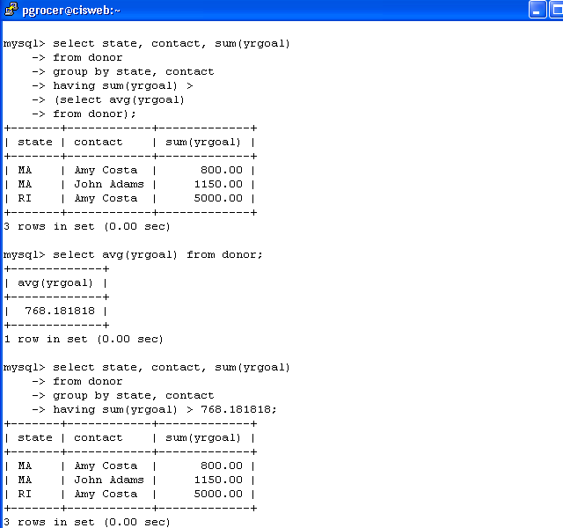
I am only using the donor table. In the inner select I am finding the average of yrgoal and then in the outer select I am showing the groups by state and contact within state where the sum of the yrgoal is greater than the average yrgoal.

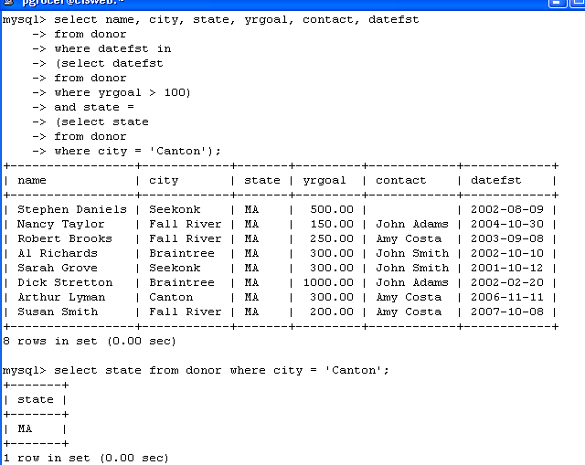

I want to see information where two criteria are met. The criteria are in an AND relationship. Each of the and relationships is an inner select. For clarity, I have put selects similar to the inner selects as stand alone selects below.

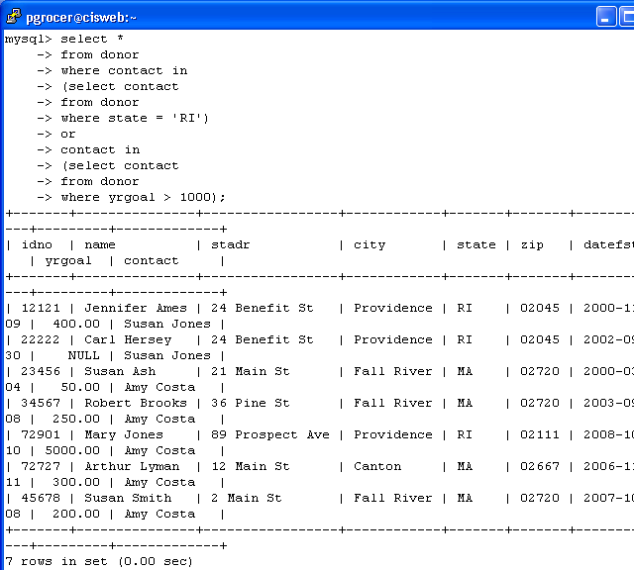
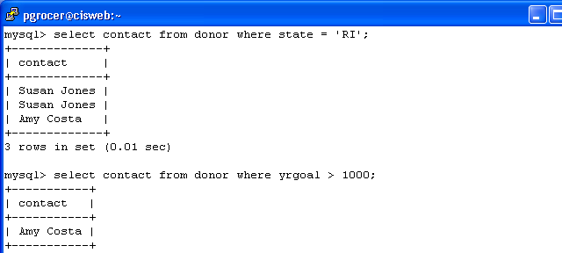
I what to select all colums from donor in the outer select where the contact is in the list that the first inner select comes up with OR the contact is in the list that the second inner select comes up with. Again I showed the two inner selects separately below to show what contact would be selected by each.

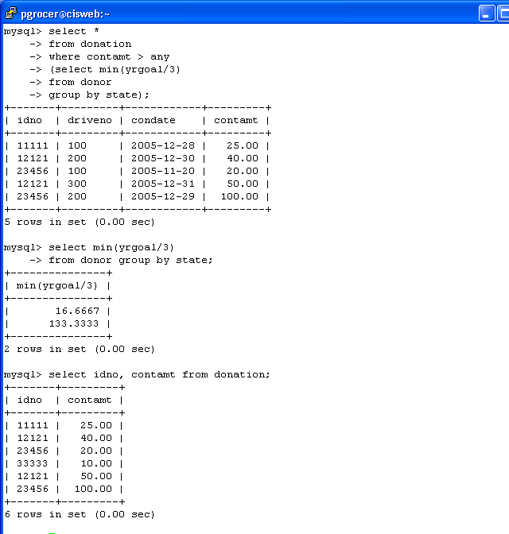
Here I am displaying all of the information from the donation table where the contamt than any of the amounts selected by the inner select. The inner select divides yrgoal by 3 and then takes the minimum of these for each state group.

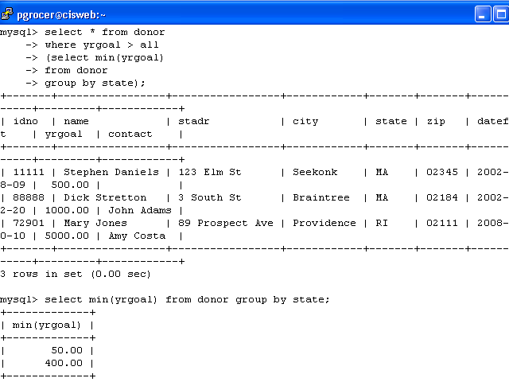
I am using ALL in the outer select. The inner select comes back with the minimum yrgoal grouped by state. The outer select then gives the information about any donor that is greater than the minimum in ALL of the states.

