How to Use Microsoft Teams
Microsoft Teams is a part of Office 365 that every student has access to. The following slides will give a brief overview of the process to get started in your classes. You will receive a link as shown in the picture below. Click on the link to move to the next slide.

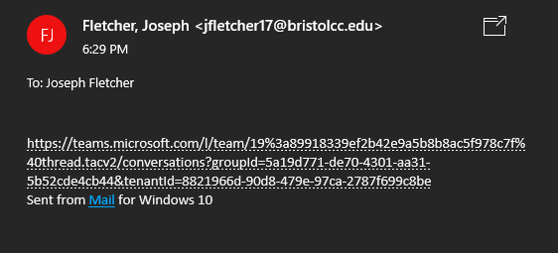

This will bring up a pop up that looks like this, it may also open up a browser window as well asking you to download the app. In the popup that shows up below simply enter your bcc email address and it will send you to another popup that looks like the bcc login page for access bcc. Enter your email an password there as well to authenticate Office 365.

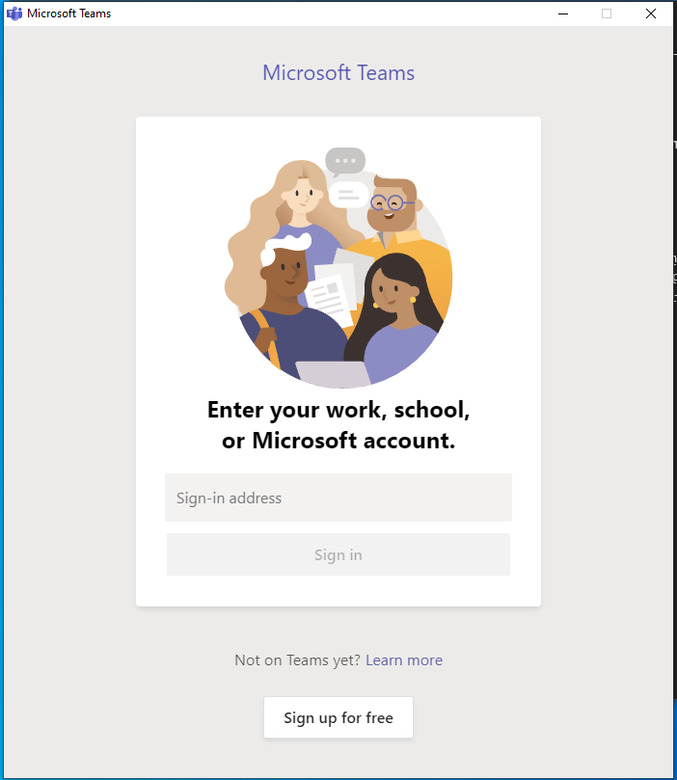
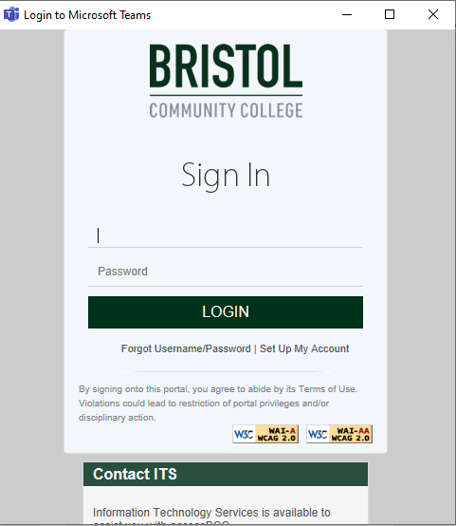

When you are finished you should automatically start up a window for teams. The below is what it looks like if you install the app on your desktop. If you are enrolled in multiple CIS classes, you will receive a link to each team for that class. If your screen looks like the top screen then click on the Team that you need assistance in, if your screen looks like the second then you are inside the team for the class that you were sent the link for and are on a page with an open chat.

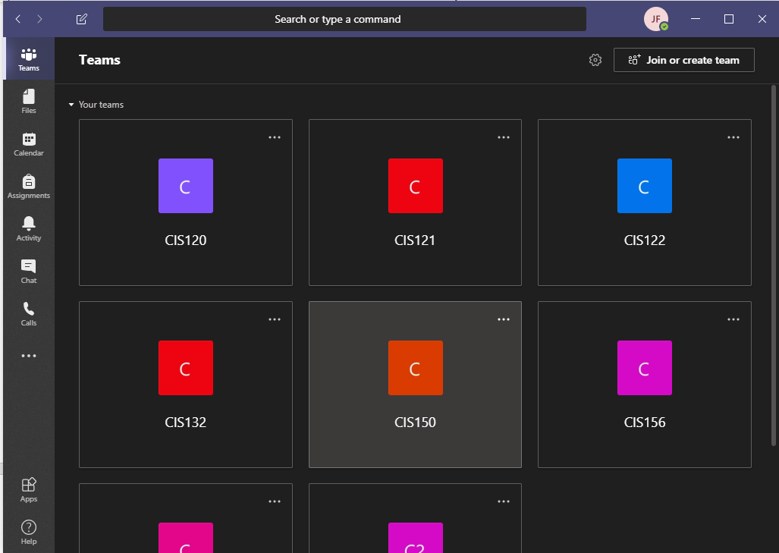
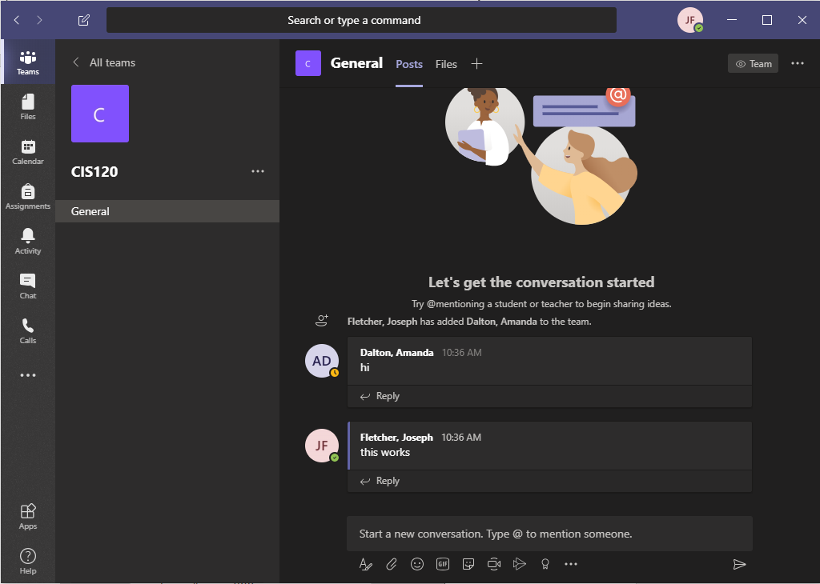

This is in the General Class and I am going to leave this open for now so if you need assistance I or another peer tutor or instructor will be notified. Simply type where the line asks you to Start a new conversation. You can use the @ to tag someone. Remember that this is an extension of the college campus so please remember to be respectful of each other.

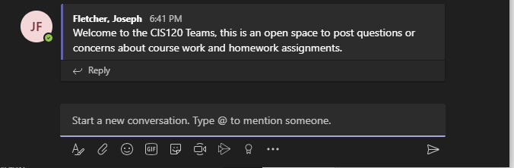

Other options :
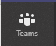
The Teams Option is the home for all of your teams or classes. Again if you have multiple classes please let me know which classes to send you a link for.
This gives you access to your OneDrive and you can upload documents into Teams. Please do not send documents through the open chat. Please see below on where to attach documents and how to initiate a private chat so that your work is protected.
This is the calendar for all teams and classes, and I will post my open labs here. If you would like to schedule one on ones then message either myself or Professor Grocer privately and we will set up a time that works for everyone to make sure you get the assistance that you are looking for.
This is the chat button, and this is going to be an important one. With this you can initiate a private chat with myself or our/your professor Once you click on the chat icon you will see the following page:
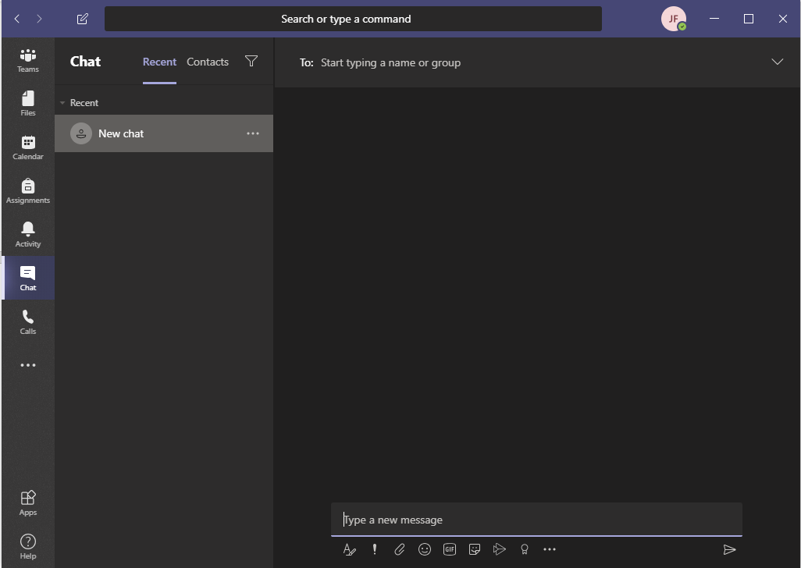
The square with the pencil starts the new chat
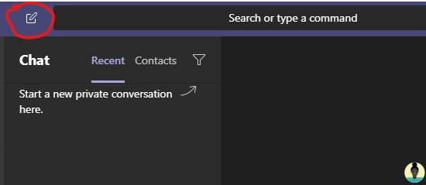

Search the name of the person you are trying to get in touch with then type the message and use the paperclip icon to send a document from your OneDrive Then click on the paper airplane in the bottom corner to send:
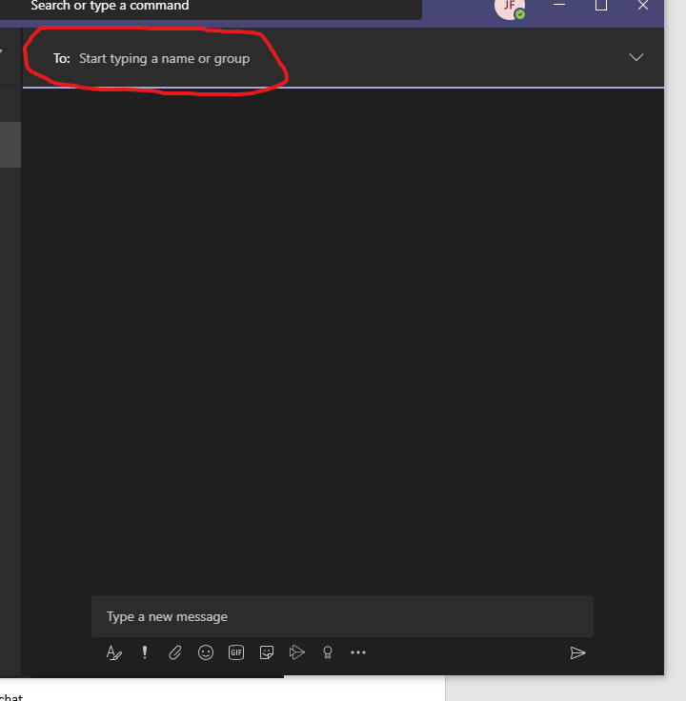
With this tool we can plan to make video calls to go over concerns and work through concepts and problems. I recommend installing the app on your phone as well and I am working on a walk through for that as well. Your phone number does remain private throughout the process and this was one of the big reasons that I choose this route. This is just a quick tutorial and I am sure that we will run into some confusion. Let me know any issues or concerns either through email or collaborate. I have created an email for this purpose alone to assist in making sure all your questions are answered.

Joseph Fletcher
moocowoftech@gmail.com

